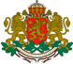
R E P U B L I C OF B U L G A R I A
NATIONAL AIR, MARITIME AND RAILWAY TRANSPORT ACCIDENTS INVESTIGATION BOARD

9 Dyakon Ignatiy str., Sofia 1000  tel. (+359 2) 940 9317  fax: (+3592) 940 9350 | bskrobanski@mtc.government.bg  bskrobanski@ntib.bg

ANNUAL REPORT

NATIONAL RAILWAY TRANSPORT ACCIDENTS
INVESTIGATION BOARD

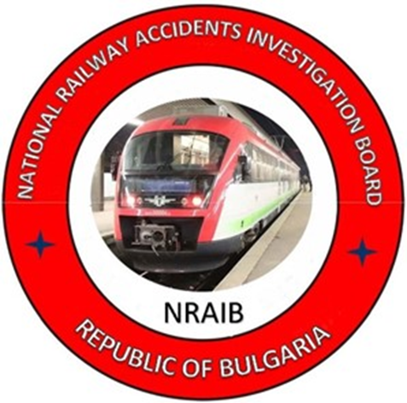

Sofia 2024

The present report is issued in accordance with:
- Directive (EU) 2016/798 of the EP and the Council of 11 May 2016, art. 24, paragraph 3;
- Railway Transport Act, SG issue 108, in force since 01.01.2007;
- Ordinance № 59, SG issue 102, in force since 05.12.2006, art. 95.
The normative acts are available at:
https://www.ntib.bg
TABLE OF CONTENTS

Preface | 4
1. INVESTIGATION BODY | 5
- Legal base | 5
- Purpose and functions | 5
- Organization of the activity  - International activity  - Participation of the NRTAIB in other events | 6  7  7
2. PROCESS OF INVESTIGATION | 9
2.1. Events that are subject to investigation | 9
2.2. Institutions related to the investigation | 10
2.3. Process of investigation and investigation body approach | 10
2.4. Safety research based on the annual reports in 2024 | 12
3. INVESTIGATIONS | 16
3.1. Review of investigations completed in 2024 | 16
3.2. Investigations started and completed in 2024  3.3. Description of the investigated accidents in 2024 | 17  17
3.3.1. Collision of shunting locomotive in the last coach of fast train № 1621 in Sofia station on 28.05.2024 | 17
3.3.2. Derailment of wagons from IDFT № 46660 between the stations Lyubenovo – Radnevo on 03.02.2024 | 19
3.3.3. Ran over of two employees by fast train № 2654 between the stations Goren Dabnik – Telish on 06.06.2024  3.3.4. Derailment of passenger train № 30114, serviced by locomotive 91520044138-3, along Anton-Koprivshtitsa interstation on 11.06.2024 | 20  22
3.4. Investigations started in 2024 and completed in 2025  3.4.1.Fire in locomotive № 91520043309-1, serviced by fast train № 8632 between the stations Svoboda – Tchyrpan on 25.08.2024  3.4.2. Fire in locomotive № 91520044202-7, serviced international fast train № 464 between the stations Zmeyovo – Tulovo on 01.12.2023  3.5. Investigated accidents and incidents in 2024 | 23  24  25  26
4. SAFETY RECOMMENDATIONS | 28
4.1. Brief summary of the safety recommendations issued by NRTAIB | 28
4.2. Safety recommendations issued in 2024 | 29
4.2.1. Collision of shunting train with locomotive № 98520055057-4 in the last coach of fast train № 1621 in Sofia station on 28.05.2024 | 29
4.2.2. Derailment of IDFT № 46660 between the stations Lyubenovo transmission – Radnevo on 03.02.2024 | 30
4.2.3. Run over and collision of two employees by fast train № 2654 between the stations Telish – Gorni Dabnik – track № 2 on 06.06.2024  4.3. Safety recommendations issued in 2024  4.3.1. Derailment of passenger train № 30114, serviced by locomotive 91520044138-3, along Anton – Koprivshtitsa interstation on 11.06.2024  4.3.2. Fire in locomotive № 91520043309-1, serviced by fast train № 8632 between the stations Svoboda – Tchyrpan on 25.08.2024  4.3.3. Hit of two employees of SE NRIC by RSSPM № 99529459017-0 between the stations Krivodol and Boytchinovtsi on 16.12.2024 | 30  30  30  31  31

Preface

The annual report presents the activity of the National Railway Transport Accidents Investigation Body in the Republic of Bulgaria. The investigated railway events and issued safety recommendations for 2023 are described as per the requirements of article 24, paragraph 3 of Directive (EU) 2016/798.
The annual report includes data on the railway accidents and incidents investigated in 2024, including the causes for their occurrence and the recommendations issued to improve the safety in railway transport to the National Safety Authority – Railway Administration Executive Agency (RAEA) at the Ministry of Transport and Communications (MTC).
The report includes information on the measures taken by the entities for their implementation and performance. Summary data from the railway events realized in 2024 and the damages presented by the Infrastructure manager- State Entity “National Railway Infrastructure Company” (SE NRIC) and the railway undertakings/carriers.
By a Decision of the Council of Ministers of the Republic of Bulgaria in 2020 was established a multimodal authority for investigating transport accidents on the safety, the “National Air, Maritime and Railway Transport Accidents Investigation Board” (NAMRTAIB/Board) within the Council of Ministers.
The Council of Ministers adopted Rules of the activity, structure and organization of the NAMRTAIB. The members of the Management Board are directly subordinate to the Prime Minister. The Board consists of three safety investigation areas in aviation, maritime and railway accidents. A Management Council consisting of three members - Heads of the respective areas, chairs the Board. The Board is a secondary spending unit within the Minister of Transport and Communications.
The activity and investigation functions in the field of the National Railway Transport Accidents Investigation Board (NRTAIB) are stipulated in the Rules of the NAMRTAIB, Railway Transport Act (RTA), and Ordinance № 59 of 05.12.2006 on railway safety management. Since 11.04.2023, the NAMRTAIB has signed an "Agreement on cooperation in the investigation of accidents and incidents in air, water and rail transport between the Prosecutor's Office of the Republic of Bulgaria, and the Ministry of Interior.

INVESTIGATION BODY

Legal base
The investigation body investigates accidents and incidents in accordance with the requirements of Directive 2016/798/EP and of the Council of 11 May 2016 on the railway safety, Rules of the Board, Railway Transport Act (RTA) and Ordinance №59/05.12.2006 for management of safety in railway transport.
Chronology and restructuring of the investigation body
In 2006, in line with the requirements of Article 21 of Directive 2004/49/EC on safety on the Community’s railways, within the Ministry of Transport and Communications (MTC) was established a specialised investigation body for the investigation of railway accidents and incidents. The "Specialized Railway Transport Accidents and Incidents Investigation Unit" (SRTAIIU), directly subordinated to the Minister for Transport and Communications. The resources to secure the investigation are provided from the Ministry’s budget.
In 2009, the Ministry of Transport, Information Technology and Communications (MTITC) established a multimodal body Directorate Unit for Investigation of Accidents in Air, Water and Rail Transport (DUIAAWRT) under the direct authority of the Minister of Transport and Communications. The resources for securing the investigations are provided by the budget of MTITC.
In 2020, was established an independent multimodal investigation authority the “National Air, Maritime and Railway Transport Accidents Investigation Board” (NAMRTAIB) at the Council of Ministers under the direct supervision of the Prime Minister.
The National Railway Transport Accidents Investigation Body NRTAIB is part of the multimodal investigation body NAMRTAIB.

Purposes and functions
The purposes of the investigation are to improve the safety in the rail transport, to avoid accidents, and to prevent significant accidents.
The prevention of the investigation body is to establish the causes for the accidents and incidents occurrence, and to elaborate relevant safety recommendations in order to improve the safety and to prevent significant accidents without seeking personal fault and responsibility.
The functions and tasks are described in detail in the European and national normative acts.
Main functions and responsibilities of the NRTAIB:
- Organizing and leading the investigation of significant accidents, accidents and incidents that occurred on the territory and at the border crossings of the Republic of Bulgaria;
- Establishing the causes, circumstances and facts related to the occurrence of significant accidents, accidents and incidents, including identification of evidence, performance of analysis, including the human factor, decision-making, preparation of expertise and documentation of events;
- Coordination of the activities for conducting parallel investigations in which the competent bodies of the Prosecutor's Office of the Republic of Bulgaria - the investigative departments of the district prosecutor's offices, and the Investigation Bodies at the Ministry of Interior (MoI) also participate;
- Preparation and sending to all the affected entities a draft final report with safety recommendations from the completed investigation of an accident or incident for expressing opinions and statements;
- After analysing the views and opinions of the involved parties, a final report containing safety recommendations is drawn up and sent to all the interested parties, which is published on the website of NAMRTAIB;
- Participation in the working meetings of the Network of National Investigation Bodies of the EU Member States, and conferences and trainings organized and coordinated by the European Union Railway Transport Agency;
- Participation in working groups for harmonization of the national normative acts with the European legislation, related to the safety and investigation of railway accidents and incidents;
- Analysis of data on occurred accidents and incidents in the railway transport system;
- Keeping an archive of the investigated accidents and incidents and maintaining an information database within the NRTAIB;

Organization of the activity
The main activity of the NRTAIB in its quality of national investigation body for railway accidents and incidents is investigation of accidents and incidents classified in accordance with the requirements of art. 20 and 22 of Directive (EU) 2016/798/EP and the Council, RTA and Ordinance № 59.
The vice-chairperson of the Management Board of NAMRTAIB manages the NRTAIB, with a scientific educational degree "doctor" in „Railway safety”, a master's degree engineer in "Operation and management of railway transport" he also chairs the accident investigation commissions;
Other investigation inspectors do not work at the NRTAIB.
The investigations are performed by a commission, which includes external independent experts on civil contracts, with professional experience and qualifications for the respective accident.
The investigations are provided with funds from the budget of the NAMRTAIB.
The decisions to initiate an investigation follow the requirements of the European and national normative acts, and are taken by the vice-chairperson of the Management Board of the NAMRTAIB in accordance with:
- Directive 2016/798/EP and the Council;
- Railway Transport Act;
- Ordinance No. 59/05.12.2006 on safety management in railway transport.
The Head of the NRTAIB shall inform in writing the Agency for Railway Transport of the European Union about any undertaken investigation of a railway event through the implemented by ERA notification system.
The investigated events are completed with a draft final report and, if necessary, safety recommendations are issued and the report is sent for opinions and statements to all the interested parties;
The Head of the NRTAIB shall inform the Agency for Railway Transport of the European Union in writing of each completed investigation, providing a digital copy of the original final report in English in accordance with the requirements of Regulation (EU) 2052/2020/EC of 24 April 2020.
After validation of the report by the Agency, it becomes publicly available on the website of the NAMRTAIB.
1.4. International activity in 2024
1. Participation of the Head of the NRTAIB in the 54th plenary session of the Network Investigation Bodies of Railway Accidents from the EU Member States held on 13 and 14 February 2023 in Brussels, Belgium;
2. Participation of the Head of the NRTAIB in a conference with topic, ERTMS 2024“held on 23 ÷ 25.04.2024 in Valenciennes, France;
3. Participation of the Head of the NRTAIB in the 55th plenary session of the Network Investigation Bodies of Railway Accidents from the EU Member States held on 15 and 16 May 2024 in Valenciennes, France;
4. Participation of the Head of the NRTAIB in the 56th plenary session of the Network Investigation Bodies of Railway Accidents from the EU Member States held on 9 and 10 October 2024 in Lisbon, Portugal;
5. Participation of the Head of the NRTAIB in a conference with topic, Integration of HOF in the risk management “held on 23 ÷ 24.10.2024 in Valenciennes, France;
6. Participation of the Head of the NRTAIB in a conference with topic, 4th multimodal conference of ERA “held on 09.12.2024 in Brussels, Belgium.
1.5. Participation in direction NRTAIB in other events
- As per the requirements of art. 11 (2) of Ordinance № 59/5.12.2006 monthly (until the tenth day of each month) operational information on the general safety indicators from the manager of the railway infrastructure, railway undertakings and the entities in charge of maintenance is sent to the National Safety Authority (RAEA) and to the Head of the National Railway Transport Accidents and Incidents Investigation Authority. The head of the NRTAIB performs analysis, summarize the received information and appoint measures for the safety improvement.
- In accordance with the requirements of art. 12 (1) of Ordinance No. 59/5.12.2006, the Head of NRTAIB and the RAEA, every year until the end of May, receive in writing the annual reports of the manager of the railway infrastructure and railway undertakings. The head of NRTAIB performs a safety analysis for the previous year based on the provided safety data.
3. The head of the NRTAIB daily (7/24) receives operational information about the accidents, incidents, and irregularities that occurred on the national railway network by the railway infrastructure manager.
4. The head of NRTAIB prepares and publishes an annual report on the activity and investigated accidents in 2024, which is sent by September 30 to the European Union Railway Agency.
5. The head of the NRTAIB interacts in the investigation process with the bodies of the pre-trial proceedings under the order of the Agreement of 11.04.2023 on interaction in the investigation of transport accidents and incidents between the Prosecutor's Office of the Republic of Bulgaria, the Ministry of Interior and NAMRTAIB.
6. In the course of the investigation, the head of NRTAIB creates working contacts with the parties and entities involved in the accident - the railway infrastructure manager, (SE NRIC), the railway undertakings/carriers, the entities in charge of maintenance, and the National Safety Authority, RAEA, the users of railway services with regard to the investigated accident, Scientific Research Technical Institutes, Centres for professional qualification of the entities, and other structures and, if necessary, with the National multi-profile transport hospitals in the country, indicated in (fig. 1.1).

Interaction of the NRTAIB with other authorities and institutions
in the investigation process

Fig. 1.1

PROCESS OF INVESTIGATION

Events that are subject to investigation
In accordance with the requirements of Directive (EU) 2016/798/EP and of the Council, the Railway Transport Act and Ordinance № 59, the National Railway Transport Accident Investigation Board investigates railway events:
- Significant railway accidents;
- Accidents and incidents that in different circumstances, could lead to significant accidents;
- At its discretion, investigates technical failures in the structural subsystems and interoperability constituents, taking into account their significance.
In the event of an accident or incident occurrence, the authorized officials on the train operation management, and the safety authorities of the railway infrastructure manager and railway undertakings shall immediately notify the Head of the NRTAIB department in accordance with their approved Safety Procedures stipulated in the Safety Management Systems as per the requirements of Directive (EU) 2016/798/EP and of the Council, the Railway Transport Act and Ordinance № 59.

Institutions related to the investigation.
In the course of the investigation, the Head of the NRTAIB contacts and includes in the commissions external experts as per the type of the occurred event. These external experts are from the following institutions:
- Technical University of Sofia;
- Higher School of Transport "Todor Kableshkov";
- Bulgarian Academy of Sciences;
- National multidisciplinary transport hospitals in the country;
- Fire safety laboratory;
- Other institutions for each specific case, indicated in (fig. 2.1).

Structure of the Investigation Commission for railway events
Fig. 2.1.

Process of investigation and Investigation Body Approach
Following the notification on the mobile phone by the authorized persons (central senior dispatcher at the railway infrastructure or railway undertaking/carrier) about an occurred accident or incident, the Head of the NRTAIB, analyses the submitted information and classifies the railway event, takes a decision for departure to the place of the accident, performs an inspection on the spot and takes a decision for undertaking an investigation. If authorities of the pre-trial proceedings have arrived on the spot, an organisation for independent inspection, taking photograph materials, controlled removal of separately damaged elements and details of railway infrastructure and rolling stock shall be established.
The security authorities of the Ministry of Interior preliminarily fence off and limit the access of outsiders and the media to the scene of the accident, in order to preserve the visible physical evidence. When there is an injury (staff and/or passengers) from the accident, the emergency medical teams are given the opportunity to provide first aid to the injury. In the event of a fire occurring in the rolling stock of the bodies of "Fire Safety and Civil Protection" (FSaCP), an opportunity is provided to extinguish the fire, after which the investigative structures begin inspections and investigation procedures.
After taking a decision, the Head of the NRTAIB appoints a commission to investigate the accident. The Commission shall include independent external experts with relevance given the type of the investigated event, stipulated in item 2.2. When deciding to initiate an investigation, the head of the NRTAIB shall inform all the interested parties in the event. Within a week after the initiation of the investigation, shall inform the European Union Agency for Railways in writing of the initiation of an investigation through the notification system in ERA.
The Chairperson of the Commission manages and coordinates the activities of the investigation independently of the parallel investigation led by the bodies of the pre-trial proceedings - Prosecutor's Office, Investigation Service, and Ministry of Interior in order to respect the requirements of the Safety Directive for independent investigation. He supports the activities related to the teams of "Emergency Medical Aid" and "Fire Safety and Civil Protection" (FSaCP). The Infrastructure Manager, the Railway Undertaking and the other legal entities involved in the event shall provide the Chairperson of the Investigation Commission with all the records and conversations of the staff involved in the train traffic management and in the accident, records from the objective control devices, records from the recording devices of the locomotives on the train operation, as well as any other important information and documents related to signalling and the rail track management.
The National Safety Authority (RAEA) shall provide any important information giving clarity on the accident or incident under investigation as well as information on the rolling stock involved in the accident, registered in the European register of the vehicles.
The Commission conducts interviews with the personnel involved in the accident, as well as with eyewitnesses and witnesses of the event and requires written testimony from all legal entities and individuals directly and indirectly related to the event.
The Commission receives the full support and assistance from the competent investigation authorities of the Prosecutor's Office and the Ministry of Interior, which conduct their own parallel investigation, in accordance with the requirements of the Code of Criminal Procedure (CPC).
The safety investigation carried out by the NRTAIB is conducted as openly as possible in order to exchange information, opinions and statements to the extent appropriate to the investigative procedures.
To the Commission are submitted the collected documents and materials provided by the Task force, which the Infrastructure manager assigns, and in which participate representatives of the parties involved in the accident.
In accordance with the requirements of Art. 71, para. 3 of Ordinance No. 59, the railway infrastructure manager shall determine the procedure for appointment and composition of a Task Force, which shall register, preserve and store the material evidence and prepare reports of findings, according to the relevant template in Appendix No. 7. A representative of the railway infrastructure manager shall be appointed as the head of the Task Force, and representatives of the interested services of the infrastructure and railway undertakings shall be appointed as members.
The Task Force shall collect all samples, books, diaries and written statements, audio and video recordings, photographic and other materials, register the presence and serviceability of the seals on the signalling equipment and rolling stock, as well as available parts of the rolling stock or other objects related to the accident and/or incident, and draw up reports of findings.
The Task Force prepares a report in accordance with Appendix No. 7 on the facts and circumstances established during the inspection of the scene of the railway accident or incident, which is signed by the chairman and members of the Task Force and submitted to the chairman of the investigation commission within 5 working days from the day of the appointment of the Task Force. If necessary, the term may be extended with the permission of the chairperson of the investigation commission in relation to the safety.
The Commission analyses the collected documents and materials, prepared statements, testimonies and expert reports, to clarify the circumstances and establish the causes that led to the occurrence of the accident.
The Head of the commission in relation to safety, depending on the severity of the investigated accident, prepares a draft of a final report, which is sent to the RAEA and the interested parties, structures and organizations, as well as to the relatives of the victims in the accident (if there are victims).
In accordance with the requirements of the Safety Directive, any accident or incident investigated within one year from the date of its occurrence shall end with a final report, and in the event of an extension, an interim report shall be drawn up describing the action taken to date. At present, the investigation body of the Republic of Bulgaria has completed all the investigated accidents within a year.
The final report shall set out the chronology of the Commission Implementing Regulation (EU) 2020/572 of 24 April 2020 on the reporting structure that shall be followed for railway accident and incident investigation reports.
If necessary, recommendations are made to improve the safety, in order to prevent other events of similar nature. The safety recommendations are addressed to the RAEA and the entities involved in the event - the railway infrastructure manager, the railway undertakings, and other interested participants in the event.
The National Safety Authority RAEA and other bodies or structures to which the recommendations are addressed shall regularly report to the Investigation Body on the measures taken and planned as a result from the recommendations.
The Head of the NRTAIB shall inform the European Union Railway Agency in writing of the completion of the investigation, sending a copy of the final report translated into English with the safety recommendations given. The final report is made publicly available on the website of the NAMRTAIB.

Safety research based on the annual reports in 2024
The presented data are downloaded from the annual safety reports of the railway infrastructure manager and railway undertakings (carriers) with registered in them totally 966 railway events, classified under categories:
• 354 accidents, incl., 5 – train collision in a railway vehicle, 188 – train collision with obstacle, 52 – derailment of RRS, 27 – level crossings accidents, 49 –accidents with persons, 13 – fire in RRS, 12 – other and 8 – suicides;
• 96 incidents including 8 – rail track damage, 37 – deformed rail track, 0 – fault in the SE, 49 – SPAD and 2 – broken wheel of RRS;
• 516 situations close to incidents (described in the table).
The summarized 41 significant railway accidents in 2024 are as per the Common Safety Indicators (CSI).
As a result of the occurred significant railway accidents, the value of the caused material damages of the railway infrastructure, and of the rolling stock amounts to BGN 3 380 606 (EUR 1 724 799).
Railway events registered in the railway network in 2024

№ | TYPE OF EVENTS | NUMBER
ACCIDENTS
1 | Train collision with railway vehicle | 5
2 | Train collision with obstacle | 188
3 | RRS Derailment | 52
4 | Level crossing accident | 27
5 | Accident with persons | 49
6 | Fire in RRS | 13
7 | Other | 12
8 | Suicides | 8
Total: |  | 354
INCIDENTS
1 | Rail track failure | 8
2 | Deformed rail track | 37
3 | Signalling equipment (SE) failure | 0
4 | SPAD (signal passed at danger) | 49
5 | Broken wheel of RRS | 2
Total: |  | 96
SITUATIONS, CLOSE TO INCIDENTS
1 | RRS failure on the RI, caused the delay | 8
2 | Rail track failure | 99
3 | Signalling equipment failure | 90
4 | Catenary failure | 36
5 | Incorrect or incoherent actions of EP from RI | 6
8 | Dispatched train without approval | 0
9 | Dispatched train to occupied interstation | 0
10 | No dropped manual barriers for train | 0
11 | Movement on unprepared route | 9
12 | Interruption of movement | 66
13 | Other situations close to incidents | 202
Total : |  | 516

Train collision with a railway vehicle
Train collision with obstacle
Derailment of RRS
Level -crossing accident
Accident with persons
Fire in RRS
Suicides
Rail track failure
Deformed rail track
Signalling equipment failure
SPAD
Broken wheel of RRS
RRS failure on RI
Catenary failure
Incorrect or non-coordinated
Sent train without agreement
Sent train on an occupied interstation
No manual barriers for train
Movement on unprepared route
Interruption of movement

Railway events with damages in the years
In 2013 compared to 2012, the deviation damages/BGN is + 206 902 BGN (+105 787 EUR)
In 2014 compared to 2013, the deviation damages/BGN is + 5 402 000 BGN (+2 762 000 EUR)
In 2015 compared to 2014, the deviation damages/BGN is – 4 842 076 BGN (–2 472 591 EUR)
In 2016 compared to 2015, the deviation damages/BGN is + 863 286 BGN. (+440 452 EUR)
In 2017 compared to 2016, the deviation damages/BGN is – 136 200 BGN (–69 597 EUR)
In 2018 compared to 2017, the deviation damages/BGN is + 1 641 141 BGN (+839 115 EUR)
In 2019 compared to 2018, the deviation damages/BGN is – 74 728 BGN (–35 135 EUR)
In 2020 compared to 2019 the deviation damages/BGN is + 1 156 291 BGN (+592 970 EUR)
In 2021 compared to 2020 the deviation damages/BGN is + 1 020 277 BGN (+517 524 EUR)
In 2022 compared to 2021 the deviation damages/BGN is + 1 645 950 BGN (+839 770 EUR)
In 2023 compared to 2022 the deviation damages/BGN is + 8 622 237 BGN (+4 402 920 EUR)
In 2024 compared to 2023 the deviation damages/BGN is – 3 380 606 BGN (–1 724 799 EUR)

All railway events and caused damages in the period 2013-2024
Damages (thousand BGN) Number of accidents
National network of the Republic of Bulgaria at 2024
● Total length of the railway network – 6440 km
● Lines with rail gauge 1 435 mm – 6 287 km, incl.:
- Continuously welded rail track – with total length 2 618 km.;
- Length of joint rail track– 1 191 km;
- double-track railway lines – 995 km;
- Length of train tracks- 1 392 km;
- Railway bridges – 995, with total length 43,1 km;
- Railway tunnels – 186, with total length 47,9 km;
- Railway switches – 6 800 units;
- Railway level-crossings – 732;
● Lines with rail gauge 760 mm – 125 km.

INVESTIGATIONS

Review of investigations completed in 2024
In 2024, the NRTAIB investigated six railway accidents.
Table 1: Investigated accidents and incidents in 2024
Type of investigated accidents and incidents | Number of accidents | Number of victims |  | Damages
Type of investigated accidents and incidents | Number of accidents | Fatalities | Seriously injured | BGN | EURO
Fire in RRS | 1 | - | - | 50 045,80 | 25 555,73
Derailment of RRS | 2 | - | - | 114 357,64 | 58 396,38
Train collision with railway vehicle | 1 | - | 8 | 104 832,76 | 53 532,53
Level crossing accident | - | - | - | - | -
Accident with persons from RRS | 2 | 3 | 2 | 4 090,00 | 2 088,54
TOTAL: | 6 | 3 | 10 | 273 326,20 | 139 573,18

Fire in RRS 1 RRS Derailment 2 RRS collision 1 Level crossing accident 0 Accidents related to dangerous goods 2 Total 6

  - Investigations, started and completed in 2024
Table 2: Investigations, started and completed in 2024
Date of the event | Visit card of the investigation | Legal base | Completed on
28.05.2024 | Railway accident – collision with shunting locomotive in the last coach of fast train № 1621 in Sofia station on 28.05.2024 | Directive 2016/798/EP, art. 20, par. 2/а, art. 115k, par. 1, item 2 of RTA, art. 78, par. 1 and 2 of Ordinance № 59 | 19.12.2024
06.02.2024 | Railway accident – derailment of wagons of IDFT № 46660 between the stations Lyubenovo – Radnevo on 03.02.2024 | Directive 2016/798/EP, art. 20, art. 115k, par. 1, item 2 of RTA, art. 78, par. 1 and 2 of Ordinance № 59 | 10.09.2024
06.06.2024 | Significant railway accident – run over of two employees by fast trainк № 2654 between the stations Goren Dabnik – Telish on 06.06.2024 | Directive 2016/798/EP, art. 20 par. 1/а art. 115k, par. 1, item 2 of RTA, art. 78, par. 1 and 2 of Ordinance № 59 | 31.10.2024
14.06.2024 | Railway accident – derailment of passenger train № 30114 between the stations Koprivshtitsa – Anton on 14.06.2024 | Directive 2016/798/EP, art. 20 par. 2 art. 115k, par. 1, item 2 of RTA, art. 78, par. 1 and 2 of Ordinance № 59 | 16.10.2024

  - Description of the investigated accidents in 2024
    - Railway accident Collision of shunting locomotive in the last coach of fast train № 1621 in Sofia station on 28.05.2024
Brief description
On 28.05.2024, a shunting train with three coaches was prepared at the Nadezhda Technical Station for FT No. 3625, headed by shunting locomotive No. 98520055057-4 (II shunting) for Sofia Station. The shunter and the shunting switchman boarded the last coach, and the second shunting switchman, together with two cleaners of the RRS at the Nadezhda Technical Station, boarded the first coach. The two women used the shunting train to travel to Sofia Station.
At around 16:30 p.m., the station dispatcher at Sofia Station had a telephone conversation with the train dispatcher of the Sofia - Septemvri section at the Sofia Railway Station regarding the regulation of the movement of FT No. 1621 and FT No. 3692, which was to arrive from Poduyane Station at Sofia Railway Unit. The second person traffic manager on duty at Sofia station reported to the station dispatcher by radio that a full test of the automatic brakes of FT No. 1621 had begun. For that reason, the station dispatcher ordered the duty traffic manager at Sofia station to ensure the movement of FT No. 3692 from Poduyane station and to accept the train on the fifth blind track.
At that time, the shunting train of the 2nd shunting, led by locomotive No. 98520055057-4, was moving along the route, and after entering the first track, it did not stop in the western part of the track, and at 16:30 p.m. (according to the speedometer tape) at km 0+088, a hit occurred in the last coach of FT No. 1621 train, displacing the entire train 15 meters forward.
As it can be seen from the testimony of the locomotive driver of locomotive No. 98520055057-4 on the second shunting, at a distance of about 20÷30 meters from the standing coaches, he felt sick and lost consciousness.

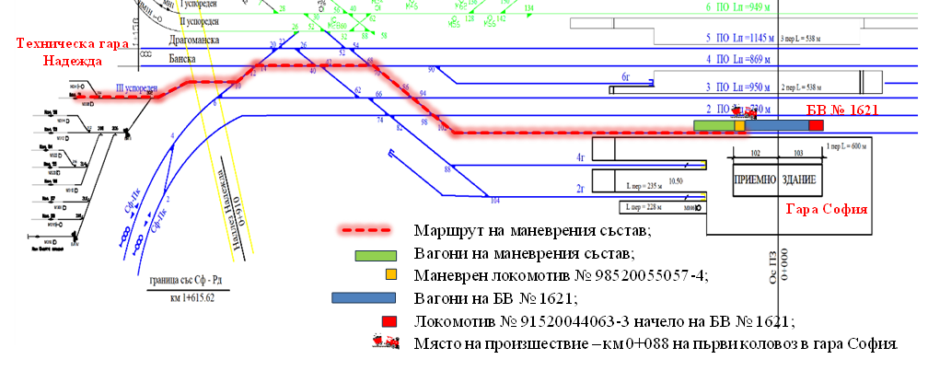
Consequences
Because of the collision, the train manager of FT No. 1621 notified the persons on duty at BDZ-PP EOOD and reported to the emergency number 112 about injured passengers from the train and personnel from the shunting crew of the second shunting.
Three passengers and five personnel were injured, including the locomotive engineer of locomotive No. 98520055057-4 of the second shunting.
Causes
The accident occurred because of a violation of a determining and contributing factor:
The determining factor for the occurrence of the accident, established by a report of findings dated 25.01.2023 for measuring the capacitors of the engine-pumps of locomotive No. 91520044169-8, is that the BOAON 3-06/88 capacitors have a reduced capacity and do not meet the nominal values. That led to a lack of starting torque of the engine-pump on the first circuit, because of which the cooling of the traction transformer oil was probably disrupted. The operating temperature of the oil increased unacceptably and led to its ignition.
Contributing factor for the occurrence of the accident:
Non-compliance with the regulatory documents for the organization of work at Sofia Station and the organization of traffic between Sofia Station and Nadezhda Technical Station;
Lack of coordination between the duty managers at Sofia station and the coach inspection section;
Lack of coordination between the duty traffic manager at Nadezhda Technical Station and the first-person duty traffic managers at Sofia station;
Therefore, the direct cause for the accident can be considered the failure of the locomotive driver and/or the shunting crew to activate the braking system of the shunting train, and/or the vigilance device.
The consequences of the event are injuries and trauma to passengers and staff, damage to the passenger coaches of the two compositions of BV No. 1621 and the train of FT No. 3625 and to the shunting locomotive No. 98520055057-4, servicing the second shunting.

Status of investigation
The investigation was closed with a final report and five safety recommendations on 19.12.2024.
    - Railway accident – Derailment of wagons of IDFT № 46660 between the stations Lyubenovo – Radnevo on 03.02.2024
Brief description
On 03.02.2024 at 06:50 a.m., IDFT No. 46660 departed from the Kapıkule border station - Republic of Türkiye, consisting of 32 wagons, 64 axles, 576 meters, 898 tons, serviced by locomotive No. 91523186012-2 of the railway enterprise "DB Cargo Bulgaria" EOOD. At Kapıkule station, before the train's departure, a wagon inspector of the railway enterprise "DB Cargo Bulgaria" EOOD carried out a technical inspection. The train arrived at 07:15 a.m. at the Svilengrad border station - Republic of Bulgaria. After the train arrived at the Svilengrad station, a customs and border inspection was carried out and the locomotives were exchanged with another locomotive No. 91521688030-1. A “D” test of the automatic train brakes was performed before the train departed. A switchman/crossing guard at Post No. 2 monitored the train’s passage. He saw that the penultimate wagon had derailed and tried to notify the traffic controller on duty at the station (according to his testimony). When IDFT No. 46660 entered the second track at Radnevo station, the traffic manager on duty noticed heavy dusting and twisting of the last two wagons of the train. When the last two wagons passed through the technical channel of the track, a side door detached from the 31st wagon, after which a second door also fell, and the last 32nd wagon rose onto the platform and tilted to the left in front of the station building. The locomotive driver felt the train pulling and took a quick stop.
Consequences
Because of the derailment, material damage was caused to the railway track, the railway switches and the signalling equipment at Radnevo station, as well as to the two derailed wagons. No personnel were injured.
From 10:20 a.m. on 03.02.2024 to 15:00 p.m. on 04.02.2024, the train traffic was interrupted in the Simeonovgrad - Nova Zagora section.
From 15:00p.m. on 04.02.2024, the train traffic in Lyubenovo transfer station - Radnevo section in the derailment zone was restored at 25 km/h, traffic through Radnevo station was restored on a fourth deviation track at a speed of up to 15 km/h, and traffic in the Simeonovgrad - Nova Zagora section was restored.
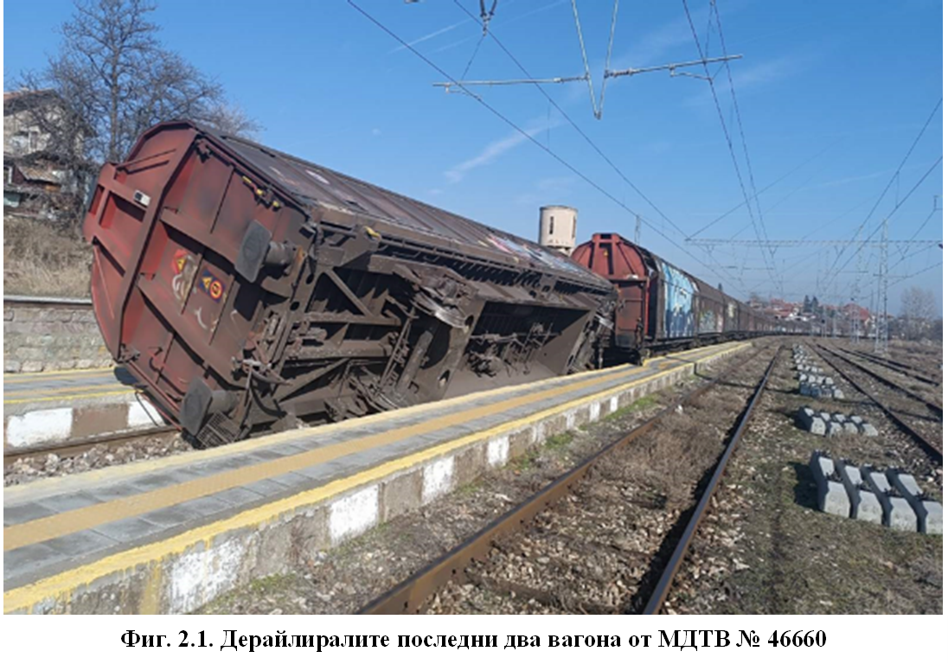

Causes
A combination of the vertical forced oscillations of the wagon (galloping), caused by the broken joints of the railway track with horizontal movement of the second axle of the penultimate wagon to the right (inner) rail due to the appearance of a horizontal transverse force before exiting the transition curve, supplemented by the small gross weight of the two-axle wagon (empty) and the peculiarities of its spring suspension, equipped with parabolic springs with bilinear characteristics. As a result of the event, minor damage was caused to about 9 km of railway track in the Radnevo - Lyubenovo transfer station section, switches No. 2 and No. 4 at Radnevo station were damaged, part of the railway track on the second track at Radnevo station, damaged elements of the signalling equipment and partial damage to the passenger platforms at Radnevo station.
Status of investigation
The investigation was closed with a final report and five safety recommendations on 10.09.2024.
    - Significant railway accident – Ran over of two employees by fast train № 2654 between the stations Gorni Dabnik – Telish on 06.06.2024
Brief description
In the Telish - Gorni Dabnik interstation, track No. 1 was closed to the movement of trains and vehicles by telegram of the General Director of the State Enterprise National Railway Infrastructure Company of the Republic of Bulgaria Railways dated 23.05.2024 for the implementation of the CRW.
Due to the production need to implement the main CRW on the railway track, by order of the Director of the Vratsa Railway Section on 06.06.2024, RSPM No. 99529423013-2 departed from Telish station at 21:08 p.m. with two train drivers to work on the railway track in the Telish - Gorni Dabnik interstation, track No. 1 at km 165+500. The chief engineer and the head of the transport group were also traveling in RSPM No. 99529423013-2.
While the train was moving along the current track No. 2, after exiting a left curve, the locomotive crew saw white lights of RSPM No. 99529423013-2 on the current track No. 1 and gave the signal “Attention”. During the passing of FT No. 2654 with RSPM No. 99529423013-2, the locomotive crew heard a blow from the front of the locomotive and the locomotive driver took a quick stop. The train stopped at km 164+769 at 22:03 p.m. When the locomotive crew inspected the locomotive, it was found that the air ducts for 5.0 and 9.5 bar on the left side of the locomotive were disconnected, the handle of the 9.5 bar crane was deformed and part of a signal vest was on the 9.5 bar duct.
While preparing RSPM No. 99529423013-2 for work, the driver saw the approaching train and also heard a bang. The other driver, who was in the control cabin of the machine, also heard the bang. The two drivers, hearing the noise of the bang, looked up and saw the chief engineer lying next to the RSPM near track No. 1. The two drivers saw blood and parts of the body of the transport group leader on track No. 2
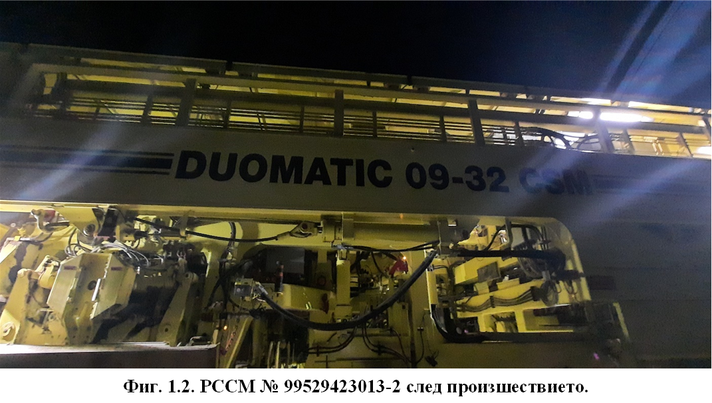
Consequences
Run-over of an employee on track No. 2. The second employee, upon getting off the RSPM from the side of track No. 2, entered the danger zone and was carried away by the air stream of the fast train passing at 91 km/h, which spun him around and he fell face down near the RSPM on track No. 1, where he was found alive by the two RSPM train drivers.
Causes
The direct cause of the accident was the two RSPM employees getting off the vehicle on the side of the adjacent current track No. 2, thereby violating the gauge of the adjacent track and entering the danger zone.
Status of investigation
The investigation was closed with a final report and six safety recommendations on 31.10.2024.

    - Railway accident – Derailment of passenger train № 30114, serviced by locomotive 91520044138-3, along Anton – Koprivshtitsa interstation on 11.06.2024
Brief description
In accordance with telegram 803/28.05.2024 of the Director General of SE NRIC on 11.06.2024 at 05:33 a.m. by order of the train dispatcher, a train and electrical "window" was allowed for the performance of MCW in the Koprivshtitsa - Anton interstation, with the departure of the vehicles from Koprivshtitsa station to km 95+300 and their return to Koprivshtitsa station by 08:45 a.m.
At 08:45 a.m. the vehicles were returned to Koprivshtitsa station.
At 08:53 a.m. by order of the train dispatcher, the Koprivshtitsa - Anton interstation was opened for train movement.
At 13:40 p.m. PT No. 30114 departed from Karlovo station to Mirkovo station. The train consisted of 2 coaches, 8 axles, 94 tons with locomotive No. 91520044138-3.
At 14:36 p.m., PT No. 30114 arrived at Koprivshtitsa station with a 2-minute delay. The train was accepted on the second receiving-departing track through the TRIS dispatching centralization.
At 14:44 p.m., FT No. 3623 arrived at Koprivshtitsa station with a 12-minute delay. The train was accepted on the first receiving-departing track through the TRIS dispatching centralization.
At 14:45 p.m., FT No. 3623 departed for Stryama station with an 8-minute delay.
At 14:48 p.m., FT No. 30114 departed for Anton station with a 13-minute delay.
At 14:50 p.m., the locomotive crew of locomotive No. 91520044138-3, serving PT No. 30114, noticed a deviation in the railway track at km 98+200 and activated the automatic train brake in the "quick stop" mode. At km 98+349, the train locomotive and the two passenger coaches derailed.
Consequences
Because of the derailment, no passengers or personnel serving PT No. 30114 were injured. Material damage was caused to the rolling stock and the railway infrastructure.
The Central Dispatching District for the transhipment of passengers has drawn up a plan from PT No. 30116 and FT No. 3625.
Causes
The direct cause of the accident was the displacement of an unregulated railway track immediately before the passage of PT No. 30114.
That led to the derailment of the locomotive and the coaches of PT No. 30114.
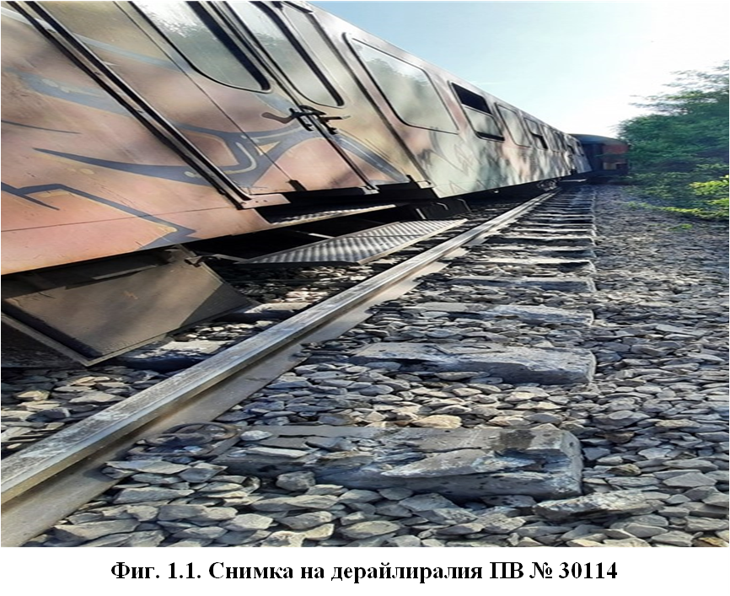
Status of investigation
The investigation was closed with a final report and two safety recommendations on 16.10.2024.

3.4. Investigations started in 2024 and completed in 2025
Table 3: Investigations, started in 2024 and completed in 2025
Date of the event | Visit card of the investigation | Legal base | Completed on
25.08.2024 | Railway accident – fire in locomotive № 91520043309-1, serviced fast train № 8632 between the stations Svoboda – Tchyrpan on 25.08.2024 | Directive 2016/798/EP, art. 20, par. 2, art. 115k, par. 1, item 2 of RTA, art. 78, par. 1 and 2 of Ordinance № 59 | 14.01.2025
16.12.2024 | Significant railway accident – hit of two employees by RSPM № 99529459017-0 between the stations Krivodol – Boytchinovtsi on 16.12.2024 | Directive 2016/798/EP, art. 20, par. 1/а, art. 115k, par. 1, item 1 of RTA, art. 78, par. 1 and 2 of Ordinance № 59 | 20.05.2025

3.4.1. Railway accident – Fire in locomotive № 91520043309-1, serviced by fast train № 8632 between the stations Svoboda – Tchyrpan on 25.08.2024
Brief description
On 25.08.2024, at 16:50 p.m., Fast train No. 8632 consisting of 4 coaches, 165 tons, 101 meters long with an electric locomotive No. 91520043309-1, operated by a locomotive driver 1st person and a locomotive driver 2nd person and a transport crew, train manager and conductor, would depart from Varna station. The train run daily on the TOS bound to Varna - Karnobat - Plovdiv and back. Personnel and PRS of the railway enterprise „BDZ-Passenger Transport“ EOOD serviced the train.
During the movement of the train before the neutral insert in the Tchyrpan - Svoboda section at km 62+250, the locomotive driver removed the working pantograph of the locomotive, coasted, and at km 61+890 raised the working pantograph. The locomotive driver, first person, looked back at the train and saw smoke and fire coming out of the rear part of the locomotive. He immediately turned off the MAD and the train continued to coast, stopping at km 60+560 in front of the entrance semaphore at Tchyrpan station. After the train stopped, the locomotive driver, first person, activated the fire-fighting system from the locomotive cabin. The locomotive driver, second person, uncoupled the locomotive from the coaches and began to extinguish the fire with portable fire extinguishers from the locomotive. They were also used three fire extinguishers from the train coaches, but to with no result.
Consequences
No passengers or personnel were injured; material damage was caused to the locomotive and to the railway infrastructure.

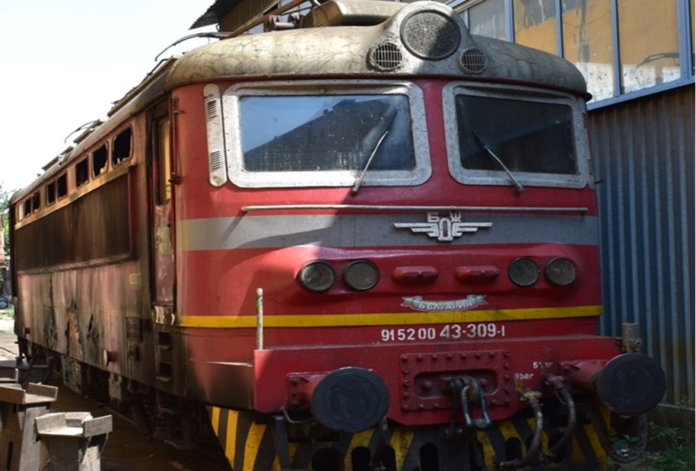

Causes
A probable cause of the fire during movement in locomotive No. 91520043309-1, serving FT No. 8632, was the thermal overheating of the power unit 221, supplying the compressor motor 235. The auxiliary rectifier 221, supplying the compressor motor, was not cooled at that time, since the fans were turned off while the train was moving along the route.
When the driver activated the FFS, it did not work. That contributed to the spread of the fire and the infliction of material damage. Due to the heavy smoke in the engine compartment, extinguishing with manual fire extinguishers was not possible.
Status of investigation
The investigation was closed with a final report and six safety recommendations on 14.01.2025.
3.4.2. Significant railway accident – Fire in locomotive № 91520044202-7, serviced international fast train № 464 between the stations Zmeyovo – Tulovo on 01.12.2023.
Brief description
By Telegram No. 149/15.12.2024, upon express request from the Vratsa Railway Station, a working train No. 70440 was assigned with parameters: motor trailer DGKu RSPM No. 99529459017-0 and wagon No. 80523936030-0, series Res, gross weight 60 tons and length 35 meters, with a schedule, departure time from Vratsa station at 08:30 a.m. and arrival at 09:55 a.m. at Medkovets station.
At 08:04 a.m., the duty traffic manager at Vratsa station held a conversation with the train dispatcher, with whom it was specified that the motor trailer RSPM No. 99529459017-0 would first refuel at the Vratsa Railway Station "Base" and after FT No. 7620 would depart according to the assigned schedule.
From 08:19 a.m. to 08:27 a.m. the RSPM was refuelled. At 08:29 a.m. the RSPM departed with the wagon, moving to the fourth receiving-departing track at the station at 08:30 a.m. From 08:30 a.m. to 08:43 a.m. the RSPM waited on the fourth receiving-departing track to depart for Medkovets station.
The RSPM driver saw the “Working Group” sign during the movement and gave a sound signal with the RSPM whistle, after which he blew it again when passing the “Pre-crossing sign”.
After the working train No. 70440 RSSM No. 99529459017-0 entered a sharp curve on the railway track and moved along it, the driver and the attendant saw the group of workers who were carrying out repairs on the railway track. According to the driver, he saw the work group and at the last moment, when the work group passed, the RSPM driver stopped.
The majority of the workers on the railway track managed to move to a safe distance from the line.
After the tractor truck passed, the WGM saw the bodies of the two workers "on the left side of the railway track" in a lifeless state.
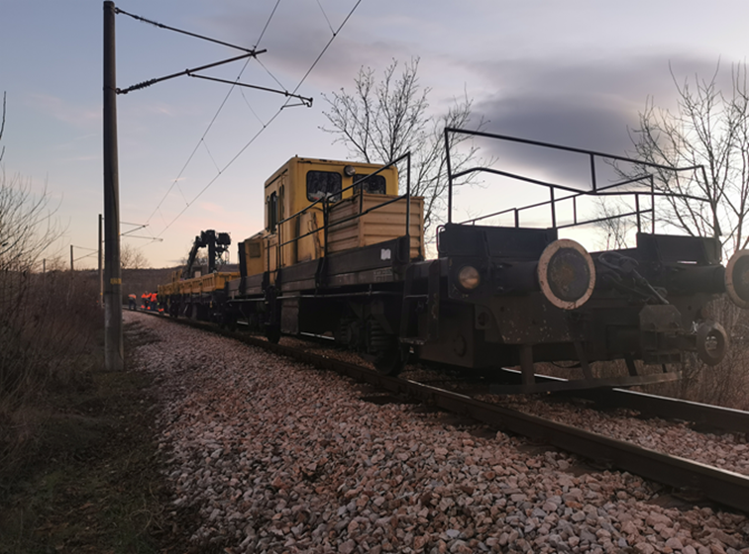
Consequences
Because of the subsequent impact from the passing RSPM, two of the workers died on the spot. The third injured worker suffered injuries and a contusion, received when the spike-screw machine was removed from the railway track. He was taken by ambulance to the Montana Hospital without life-threatening injuries.
Causes
Unsecured security for the working group (signalmen) at the work site in a curve with a radius of 400 m.
Untimely activation of the automatic train brake of the RSPM to reduce the speed of movement after it was established that there was a working group and light track machinery on the railway track.
Status of investigation
The investigation was closed with a final report and seven safety recommendations on 20.05.2025.

Investigated accidents and incidents 2024
Table 4: Investigated accidents and incidents in the period 2012÷2024
Investigated events | 2012 | 2013 | 2014 | 2015 | 2016 | 2017 | 2018 | 2019 | 2020 | 2021 | 2022 | 2023 | 2024 | Total
Train collision in railway vehicle | - | - | - | 1 | - | - | - | 1 | - | - | 1 | - | 1 | 4
Collision with obstacle | - | - | - | - | - | - | - | - | - | - |  | - | - | 0
Train derailment | - | 1 | 2 | 1 | 4 | 5 | - | 2 | 2 | 6 | 1 | 1 | 2 | 27
Accident at level-crossing | - | - | 2 | - | - | - | - | 1 | - | - | 1 | - | - | 4
Accident with persons of RRS in motion | - | - | - | - | - | - | - | - | - | - | 1 | 1 | 2 | 4
Fire in rolling stock | 1 | 2 | 2 | 1 | 4 | 1 | 2 | 2 | 1 | 1 | 1 | 3 | 1 | 22
Accident with dangerous goods | - | - | - | - | 1 | - | - | - | - | - | - | - | - | 1
Incidents | - | - | - | - | - | - | - | - | - | - | - | - | - | 0
Total: | 1 | 3 | 6 | 3 | 9 | 6 | 2 | 6 | 3 | 7 | 5 | 5 | 6 | 62

Total Incidents
Accidents with dangerous goods Fire in RRS
Accident with person caused by RRS in motion Level crossing accident
Train derailment Train collision with obstacle
Train collision with railway vehicle

SAFETY RECOMMENDATIONS
4.1. Brief summary of the safety recommendations that the NRTAIB issued
The safety recommendations given by the National Railway Transport Accident Investigation Board (NRTAIB) are aimed at improving safety and preventing other accidents of similar nature. The recommendations are addressed to the National Safety Authority (RAEA), the Railway Infrastructure Manager (NRIC), railway undertakings and other persons related to the maintenance of rolling stock to take measures and actions to improve the safety in railway transport and to avoid other accidents.

Table 5: Issued and implemented recommendations in the period 2012÷2024
Year | Given recommendations | Status of implementation of the recommendations
Year | Given recommendations | Implemented | In process of implementation | Accepted and implemented
2012 | 7 | 2 | 1 | 4
2013 | 16 | 8 | 6 | 2
2014 | 16 | 7 | 4 | 5
2015 | 10 | 8 | 2 | 0
2016 | 27 | 19 | 5 | 3
2017 | 28 | 17 | 5 | 6
2018 | 11 | 11 | 0 | 0
2019 | 23 | 20 | 2 | 1
2020 | 15 | 8 | 2 | 4
2021 | 25 | 20 | 0 | 5
2022 | 26 | 19 | 2 | 5
2023 | 28 | 18 | 4 | 6
2024 | 31 | 18 | 10 | 3
Общо | 263 | 175 | 43 | 44
Given recommendations Implemented In process of implementation Accepted Total

4.2. Safety recommendations, issued in 2024
4.2.1. Railway accident – Collision of shunting train with locomotive № 98520055057-4 in the last coach of Fast train № 1621 in Sofia station on 28.05.2024
Safety recommendations
• Recommendation 1 proposes that the SE NRIC and BDZ PP EOOD familiarize the interested personnel with the content of the report;
• Recommendation 2 proposes that the personnel related to ensuring train traffic and shunting work of the SE NRIC, as well as the personnel related to performing shunting work of BDZ PP EOOD, performing their duties at Sofia Station, be re-equipped with mobile terminals for using the existing GSM-R radio connection in order to carry out a permanent objective recording of the conversations;
• Recommendation 3 proposes that the SE NRIC and BDZ PP EOOD, until the introduction of the route-computer interlocking at Sofia Station in regular operation, in the daily briefings conducted for the personnel of both enterprises, pay attention to strict compliance with the Instruction regulating the organization of traffic and shunting work, as well as performing tests of the train brakes of departing trains in order to improve and refresh the knowledge of the personnel;
• Recommendation 4 proposes that BDZ PP EOOD, until the introduction of the route-computer interlocking at Sofia Station into regular operation, turn on and seal the devices for monitoring the vigilance of the shunting locomotives;
• Recommendation 5 proposes that, in order to achieve higher efficiency in shunting work, SE NRIC and BDZ PP EOOD change the shunting arrangements and plans with a view to the simultaneous movement and composition of several trains departing from the same track according to Plan Rev.Ⅱ-24 at Sofia Station.
Undertaken measures
Five recommendations – not implemented.
4.2.2. Railway accident – Derailment of IDFT № 46660 between the stations Lyubenovo transmission – Radnevo on 03.02.2024
Safety recommendations:
• Recommendation 1 proposes that SE NRIC and DB Cargo Bulgaria EOOD familiarize the interested personnel with the content of the report.
• Recommendation 2 proposes that DB Cargo Bulgaria EOOD, when accepting rolling stock at border stations that will be serviced by the railway undertaking, increase the quality and control when performing technical inspections.
• Recommendation 3 proposes that SE NRIC analyse the data provided by the licensed independent body ,,TINSA” OOD, measured with the EM-120 Track Measurement Laboratory on 14.11.2023 in the Lyubenovo transfer station - Radnevo section and take measures to eliminate the vertical deformations of the rails in the joints exceeding the requirements of class “C” for speed ≤ 60 km/h.
• Recommendation 4 proposes that the State Enterprise NRIC should align the differences in the parameters for permissible deviations in the level of the tracks between the "Instructions for the Design and Maintenance of the Superstructure of the Railway Track and Railway Switches" and the "Temporary Instructions for the Assessment of the Railway Track with the EM-120 Plasser & Theurer Track Measuring Vehicle" at different speeds.
● Recommendation 5 proposes that the State Enterprise NRIC should increase control over the Transport Safety Service (Chief Inspector of the Railway Infrastructure Inspectorate) regarding the quality of the preparation of reports under Appendix 7, as well as the precise, complete and accurate completion of the finding protocols according to the samples presented in Ordinance No. 59.
Undertaken measures
Five recommendations – implemented.
4.2.3. Significant accident – Run over and collision of two employees by fast train № 2654 between the stations Telish – Gorni Dabnik – track № 2 on 06.06.2024
Safety recommendations:
• Recommendation 1 proposes that SE NRIC and BDZ PP EOOD familiarize interested personnel with the content of this report;
• Recommendation 2 proposes that SE NRIC "Inspection of Health and Safety at Work" undertake systematic checks on the quality of the briefings conducted by managers and the records in the briefing books;
• Recommendation 3 proposes that SE NRIC "Inspection of Health and Safety at Work" organize and conduct training for managers conducting briefings for personnel, paying particular attention to the attendant hazards in the types of work on the railway track (manual and mechanized);
• Recommendation 4 proposes that SE NRIC "Inspection of Health and Safety at Work" carry out inspections in the divisions regarding the analysis and supplementation of the risk assessment in connection with the issued alarm bulletin of 19.06.2024;
• Recommendation 5 proposes to the State Enterprise NRIC, for sites carried out in an economic manner by the relevant divisions, to prepare and approve a technology for carrying out the relevant type of repair;
• Recommendation 6 proposes to BDZ PP EOOD that the locomotive personnel operating traction rolling stock when passing sections with single and double track railway lines, on which repair activities are carried out on the railway infrastructure, be alert, with readiness for quick stopping.
Undertaken measures
Six recommendations – implemented.
4.3. Safety recommendations issued in 2024
4.3.1. Railway accident – Derailment of passenger train № 30114, serviced by locomotive 91520044138-3, along Anton – Koprivshtitsa interstation on 11.06.2024
Safety recommendations:
● Recommendation 1 proposes that SE NRIC and BDZ PP EOOD familiarize the interested personnel with the content of the report;
● Recommendation 2 proposes that SE NRIC, when carrying out repair activities in areas with unguided rail tracks, comply with the requirements of the "Technical norms for the arrangement, construction and repair of continuously welded rail track" both by the repair contractors and by the investors;
Undertaken measures
Two recommendations – implemented.
4.3.2. Railway accident – Fire in locomotive № 91520043309-1, serviced by fast train № 8632 between the stations Svoboda – Tchyrpan on 25.08.2024
Safety recommendations:
• Recommendation 1 proposes that the State Railways of Bulgaria and BDZ-Passenger Transport EOOD inform the interested personnel about the content of the report;
• Recommendation 2 proposes that BDZ PP EOOD undertakes the replacement of electrolytic capacitors of the R-C groups with dry-type capacitors of locomotives series 44 and 45;
• Recommendation 3 proposes that BDZ PP EOOD install technical means (thermostats) for temperature control of rectifier groups 020 and 022 of locomotives series 44 and 45;
• Recommendation 4 proposes that BDZ PP EOOD restores the power supply of the electronic control unit of the auxiliary machines Y2 from its own transformer 222, in accordance with the design schemes of the manufacturing plant for series 44 and 45;
• Recommendation 5 proposes that BDZ PP EOOD organizes and carries out major repairs of the locomotives of series 44 and 45, which are expired operational resource, necessary in operation;
• Recommendation 6 proposes that BDZ PP EOOD increase control and accountability of the implementation of planned and necessary repairs.
Undertaken measures:
One recommendation – implemented.
Five recommendations accepted – not implemented.
4.3.3. Significant railway accident – Hit of two employees of SE NRIC by RSSPM № 99529459017-0 between the stations Krivodol and Boytchinovtsi on 16.12.2024
Safety recommendations:
• Recommendation 1 proposes that SE NRIC familiarize the interested personnel with the content of the report;
• Recommendation 2 proposes that RAEA amend and supplement Ordinance No. 58, Art. 179, Para. 3 regarding the movement of “Specialized machines for maintaining the railway track and the overhead contact network” on the railway infrastructure, to be carried out with included recording speedometers;
• Recommendation 3 proposes that SE NRIC amend and supplement Working Procedure RP 2.55-08 “Instructions for the technical requirements, operation and maintenance of rail self-propelled specialized machines”, Chapter Two “Basic technical and operational requirements for RSPSM”, Art. 16: “All RSPSM must be equipped with a working recording speedometer”;
• Recommendation 4 proposes that the SE NRIC amend and supplement the Working Procedure RP 2.62 "Instructions for the operation of the driver of the RSPSM", to create a new section "Operation of a recording speedometer";
• Recommendation 5 proposes that the SE NRIC train all drivers operating the RSPSM in handling the on-board tachograph, setting a circular diagram, adjusting the clock and other manipulations related to the operation of the tachograph;
• Recommendation 6 proposes that the SE NRIC control and do not allow the movement of RSPSM on the railway infrastructure with a faulty, non-switched tachograph and without a new circular diagram placed in the tachograph for recording the movement before starting work;
• Recommendation 7 proposes that the SE NRIC restore the position of "Working Group Signalman" in the railway sections in accordance with the required regulatory acts on safety when working on the railway track.
Undertaken measures:
Four recommendations – implemented.
Three recommendations accepted – not implemented.

Pursuant to the requirements Directive (EU) 2016/798 and Ordinance № 59 on the railway safety management, the addressees of recommendations regularly report to the Head of the National Railway Transport Accidents Investigation Board (NAMRTAIB AB) on the measures taken or planned for implementation as a result from the issued recommendations.

Dr Eng. Boycho Skrobanski
Deputy President of the NAMRTAIB AB
Head of NRTAIB Unit

