FINAL REPORT

from

Investigation of railway accident – fire in a coach of passenger train № 50215 while staying in Pernik marshalling yard on 04.09.2021

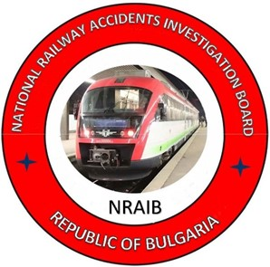

2022
OBJECTIVE OF INVESTIGATION AND EXTENT OF RESPONSIBILITY
The National Air, Maritime and Railway Transport Accidents Investigation Board (NAMRTAIB), which is an independent body performs the investigation of significant accidents, accidents and incidents. The National Board is within the Council of Ministers (CM) of the Republic of Bulgaria, and aims to find the circumstances and causes that led to the accidents and incidents occurrence in order to improve the safety and to avoid such in future, without searching personal fault and responsibility.
The investigation is performed in accordance with the requirements of Directive (EU) 2016/798 of the European Parliament and of the Council of 11 May 2016 on railway transport safety, the Railway Transport Act (RTA), Ordinance No59 dated 5.12.2006 on the rail transport safety management, and Ordinance No Н-32 dated 19.09.2007 on the coordination of the activities and information exchange during the railway accidents and incidents investigation, as well as per Agreement dated 17.04.2018 on the interaction during investigation of accidents and incidents in the air, maritime and railway transport between the Prosecutor's Office of the Republic of Bulgaria, Ministry of Interior, and the Ministry of Transport, Information Technology and Communications.
The Reports follow the requirements of Regulation (EU) 2020/572 of the Commission dated 24 April 2020 on the reporting structure for railway accident and incident investigation reports.

TABLE OF CONTENTS
№ | Title of section | Pg.
 | Summary | 5
 | Investigation | 8
 | Description of the event | 11
 | Analysis of the event | 18
 | Conclusions | 33
 | Safety recommendations | 38

ABBREVIATIONS, USED IN THE REPORT

BDZ PS Ltd. – ,,BDZ-Passenger Services“ Ltd.
BDZ Cargo Ltd. – ,,BDZ-Cargo“ Ltd.
SE NRIC – State enterprise „National railway Infrastructure Company “(railway infrastructure manager)
RAEA – Railway Administration Executive Agency (National safety authority)
NAMRTAIB – National Air, Maritime, and Railway Transport Accidents Investigation Board (Independent Specialized National Investigation Body)
WD Nadezhda – Wagon Depot Nadezhda (passenger coaches)
ECM – Entity in Charge of Maintenance
RRI МН-68 – Route Relay Interlocking type МН-68
ST – Shunting train
TF – Task Force
HTM – Heavy Tamping Machine
TOaSAR – Train Operation and Shunting Activity Rules
RITOR – Railway Infrastructure Technical Operation Rules
RRS – Rail Rolling Stock
LDP – BDZ-Cargo Ltd. Locomotive Depot Prescription
SMS – Safety Management System
TMWI – Technician-mechanic wagon inspector
DCCM – Device for communications, connections and messages
RDLD – Relay Device with key/lock dependency
RTA – Railway Transport Act
Ordinance № 59 – Ordinance on the rail transport safety management

- Summary
  - Brief Description of the Event.
On 04.09.2021, fast train No 7623 arrived from Vidin station at Sofia final destination station at 17:10 p.m. At 19:15 p.m. the train composition was submitted to Nadezhda WD for equipment, cleaning and technical inspection. At 20:30 p.m. after completion of the necessary inspections and equipment in the depot, the composition was handed over for operation. The composition was drawn and composed on the seventh track in Sofia station for passenger train No50215 in Pernik station direction.
The train departed under schedule from Sofia station at 22:30 p.m. with route Sofia - Vladaya — Pernik marshalling yard — Pernik. The train was operated by electric locomotive No91520044098-9 with locomotive crew — locomotive driver first person and locomotive driver second person and transport crew train manager and conductor. A railway undertaking for passenger transport, “BDZ-Passenger Services” Ltd., operated the train.
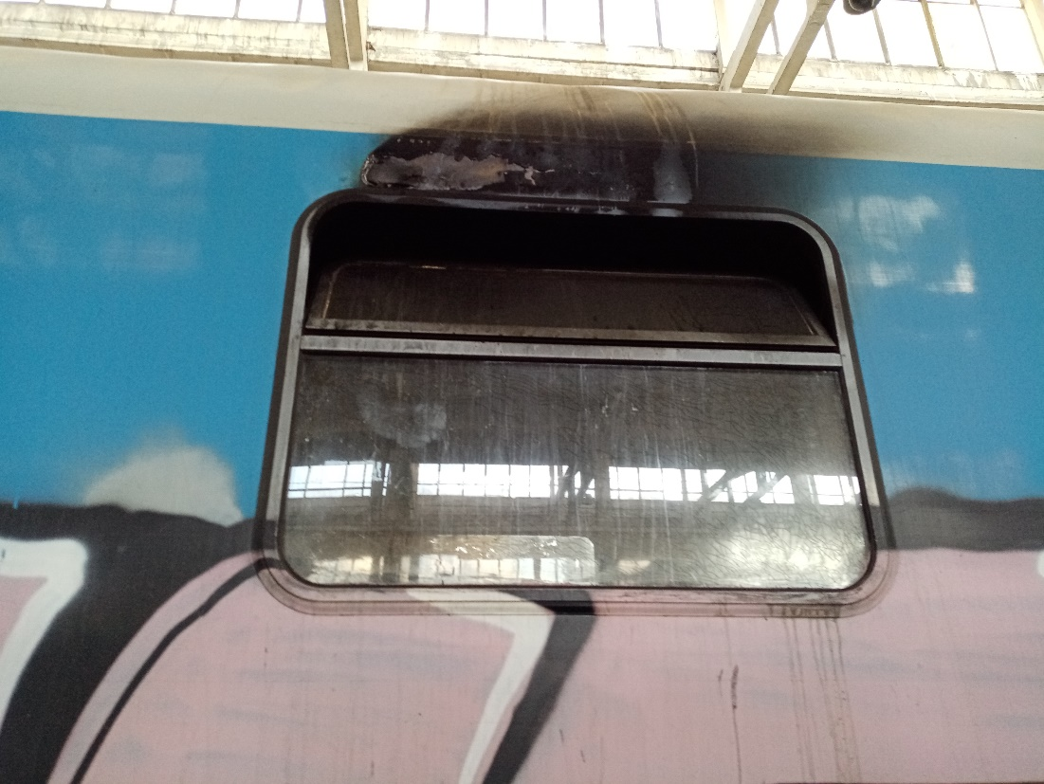
The train arrived at Pernik marshalling yard at 23:18 p.m. on the fourth main track and after a one- minute stay, it departed at 23:19 p.m. When the train departed, unknown person (passenger) activated the emergency brake, and the train stopped. The traffic manager on-duty noticed smoke coming out from the last coach No 51522563019-0, the fifth of the train composition (Figure 1.1). He took a fire extinguisher from the station and went to the coach. When opening, the coach door, he noticed that thick black smoke emerged from the inner part of the coach and found that the coach was burning and did not enter. The train staff notified the single emergency telephone 112 on fire emerged in the passenger train. The voltage was switched off at 23:23 p.m. The passengers were evacuated from the train at a safe distance and the coach was detached from the train composition. After a special vehicle of FSaCP-Pernik arrived at 23:40 p.m., the fire in the coach was extinguished at 00:20 a.m. The voltage in the station was switched on at 00:48 a.m. Test “D” was performed to PT No50215 and departed at 00:48 a.m. to Pernik station, final destination station of the train.
Fig. 1.1. Burnt coach № 51522563019-0 – outside perspective.
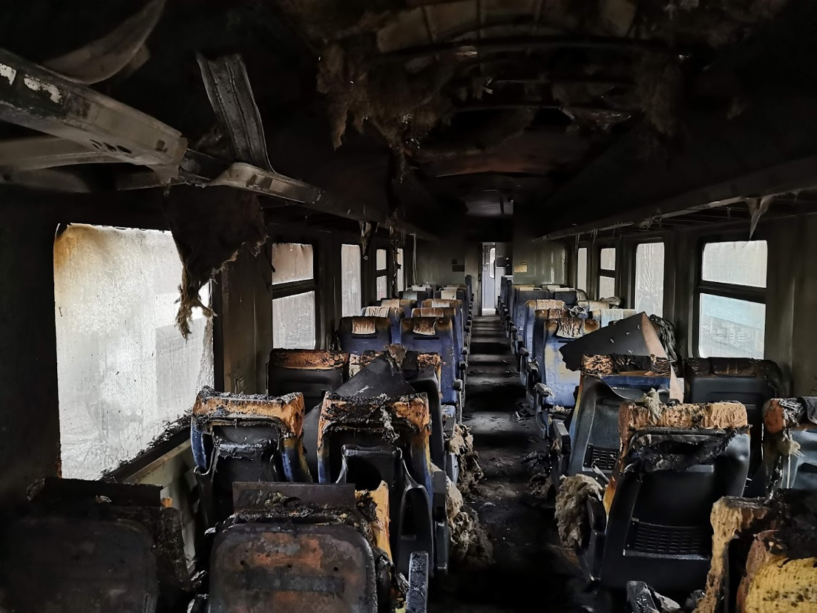
As a result from the fire occurred in PT № 50215 there were no injured passengers and staff, damages were caused to the passenger coach (bigger part of the compartment was burnt) (fig. 1.2).
Fig. 1.2. Fired compartment in coach № 51522563019-0.
The train traffic through Pernik marshalling yard was not interrupted.
  - Location and time of the event occurrence.
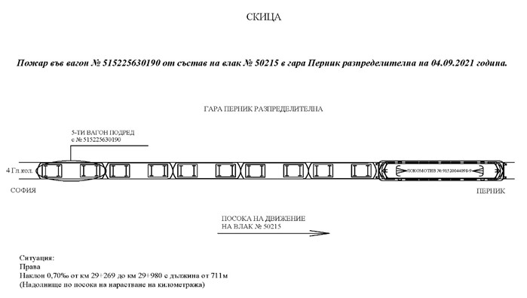
PT No 50215 arrived under schedule and stopped at 23:18 p.m. on the fourth main track in Pernik marshalling yard. At that moment there were no indications for fire in the fifth last coach № 51522563019-0 of the train. After departure at 23:19 p.m., the train was compulsorily stopped by activated emergency train brake from a passenger. The traffic manager on-duty was the first who found the fire in the last coach of the train (fig. 1.3).
Fig. 1.3. Sketch of the ignition of coach № 51522563019-0 – fifth in the composition of PT № 50215.

  - Factors determining the event.
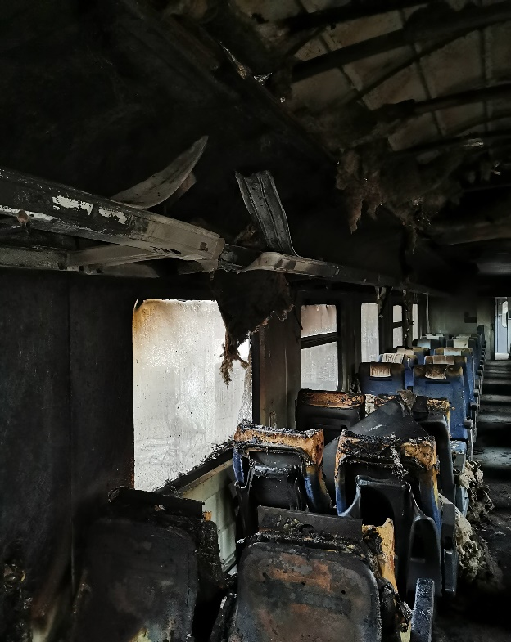
The determining factor for the accident occurrence is the ignition of part of the electrical equipment of the one-compartment (compartment free) passenger coach No 51522563019-0 in the area of the luggage compartments over the seats from row 8 in ascending direction of the seats number (fig. 1.4).
Fig. 1.4.
Row 8
Contributing factors to the occurrence of the accident are:
Presence of flammable elements of the electrical equipment.
The fact that the coach is not equipped with a fire alarm system has contributed to the expansion of the fire and its untimely detection and extinction before occurrence of significant damages to the interior equipment of the coach.
  - Direct causes and consequences of the event.
The most probable direct cause for the occurrence of the accident is forced ignition from an external source in the area of the loudspeaker and the matching transformer of the sound system located in the area for placing passengers' luggage above the seats in the coach.
1.5. Safety recommendations and addressees to which they are addressed.
The Investigation Commission proposes safety recommendations addressed to the National Safety Authority, the Railway Administration Executive Agency, and relevant to both entities involved in the accident.
• Recommendation 1 proposes that SE NRIC and BDZ PS Ltd. shall acquaint the interested staff with the content of this report.
• Recommendation 2 proposes that BDZ PS Ltd. when renewing or upgrading (capital repair) passenger coaches, shall include in the passenger coaches’ specification, technical requirements concerning the equipment and areas associated with fire hazards as the coaches shall be equipped with an early-stage fire detection system (fire alarm system).
• Recommendation 3 proposes BDZ PS Ltd. when renewing or upgrading (capital repair) passenger coaches, shall include in the passenger coaches’ specification, technical requirements, by the virtue of which, when a fire is detected, an optical and audible alarm shall be activated in the coach.
• Recommendation 4 proposes BDZ PS Ltd. when renewing or upgrading (capital repair) all series of passenger coaches, shall envisage in the technical specification the installation of video recording cameras at both ends of the coach in order to monitor the actions of the passengers.

- Investigation
  - Decision for starting the investigation.
The decision to initiate an investigation of the accident has been taken with respect to the seriousness and its impact on the safety. The investigation aims to prevent this type of accidents, which in similar circumstances could lead to significant accidents, including technical damages in the structural subsystems.
  - Motives for the decision to initiate the investigation.
The Decision to initiate the investigation is based on art. 20, paragraph 2, (а) and (c) of Directive (EU) 2016/798, art. 115к, paragraph 1, item 2 of RTA, art. 76, par. 1, item 2 of Ordinance No 59 dated 5.12.2006, and by Order of the NAMRATIB for assignment of Commission for investigation of the railway accident.
  - Scope and restrictions of the investigation.
The scope of the investigation examined the seriousness of the accident and analysed the railway safety breaches to the operation, repair and maintenance of the rolling stock (passenger coaches).
In view of the damages to the rolling stock, the investigation is focused on the performed capital repair (overhaul) in Wagon Plant Intercom-Dryanovo within the period 27.02-22.04.2020, the passenger coach maintenance, which “BDZ-Passenger Services” Ltd. performed. The investigation is also focused on the circumstances that caused the fire in coach № 51522563019-0 from the composition of PT №50215 while operating between the stations Dragichevo and Pernik marshalling yard.
  - Competences of the persons, involved in the investigation.
The composition of the commission includes external independent experts - habilitated persons from the higher scientific circles and experts with free profession with qualification and professional orientation in fields of activity – railway infrastructure, and rail rolling stock.
  - Communication and consultations with the persons and entities, involved in the event.
The Task Force, which includes representatives from both entities, was consulted during the investigation. The Head of the Task Force has collected documents and samples, as well as the downloaded recordings from the locomotive recording device. Interviews were conducted with the persons directly involved in the accident. The entities were requested, and provided information on the repair and maintenance of the burnt coach of the train. Interviews were conducted with the safety authorities of both entities and the managers of the railway undertaking BDZ PS Ltd.
  - Degree of cooperation from the participating entities.
During the investigation, the entities BDZ PS Ltd. and SE NRIC fully cooperated with the Investigation Commission in the NAMRATIB.
The Investigation Commission required additional documents and materials from BDZ PS Ltd. and Wagon Plant “Intercom”-Dryanovo, which performed the repair of coach No 51522563019-0 in order to establish the circumstances and causes for the accident.
  - Methods and techniques of investigation and analysis.
Following the inspections and analysis carried out in Nadezhda WD on 05.09.2022, the member of the Management Board of the NAMRATIB, in accordance with Article 71(2) of Ordinance No 59, classified the event. After that, he informed the persons involved in the accident (SE NRIC and BDZ PS Ltd.) informed the parties involved in the accident that an investigation had been undertaken.
In accordance with the requirements of Article 25 paragraph 1 of Directive 2016/798 and Article 80 of Ordinance No 59, on 17.09. 2021 the event was notified to the European Railway Agency (ERA) under No BG 10124, an investigation of railway accident by NIB - BG.
Interviews were conducted with the personnel involved in the accident by the two entities. The recordings were requested to be downloaded from the recording devices of the locomotive.
On 23.09.2021, in the wagon depot Nadezhda, in the presence of representatives of the Task Force of the entities and of “Wagon Plant-Intercom” JSC that performed the repair of coach No 51522563019-0, inspections and measurements of the burnt coach No 51522563019-0 were carried out, and a Statement of findings on the technical condition of the coach was drawn up.
On 07.10.2021, in a wagon depot Nadezhda, the Investigation Commission at the NAMRATIB carried out repeated inspections and requested the measurement of electrical circuits concerning the electrical lighting, conversational system and the contacts powered with 220V in the burnt coach No 51522563019-0. The emergency brake was found to have been applied at Pernik marshalling yard by the only passenger in the wagon who got off at the station.
On 10.12.2021, in the wagon depot Nadezhda, the Investigation Commission at the NAMRATIB again carried out inspections and asked BDZ PS Ltd. to submit additional documents concerning the capital repairs of the coach in Wagon Plant Intercom JSC, and the registered failures during its operation.
The Investigation Commission carried out an analysis of the data collected from the registration device of locomotive No 91520044098-9 establishing the motion parameters of PT No 50215 on 04.09.2021 between the station Dragichevo and Pernik marshalling yard.
With reference to Article 73(3) of Ordinance No 59, due to non-compliance with the deadline for the provision of the necessary information by the participating entities, the Head of the Task Force requested an extension of the deadline from the Chairperson of the Investigation Commission at NAMRATIB, who granted authorisation by 21.09.2021.
On 21.09.2021 in the TSRI - Sofia, the Chairman of the Investigation Commission at NAMRATIB received the collected documentation submitted by the Head of Task Force II-nd category concerning an accident - occurrence of fire in the fifth coach No 51522563019-0 of PT No 50215 in Pernik marshalling yard, around 23:19 p.m. on 04.09.2021.
  - Difficulties faced during the investigation.
In relation to the requirements of Article 69(1)(2) of Ordinance No 59, the member of the Management Board of NAMRATIB with competence to investigate railway accidents and incidents has not been notified on the accident by the railway infrastructure manager SE NRIC and the railway undertaking BDZ PS Ltd.
On 05.09.2021 at 09:15 a.m., after the notification received from the dispatcher on-duty of BDZ PS Ltd., the member of the Management Board of NAMRATIB analysed the information submitted and took action to carry out inspections of the burnt coach in Nadezhda - Sofia WD.
  - Interaction with the judicial authorities.
During the investigation, the communication between the Investigation Commission and the parties involved in the accident was at the necessary level.
After the performed inspections by the authorities of the Ministry of Interior at Pernik marshalling yard, around 00:30 a.m. on 04.09.2021, the burnt coach was released from supervision. In the course of the investigation, information was exchanged with the authorities of the Ministry of Interior and the FSaCP involved in the inspection and extinguishing of the fire.
  - Other important information for the investigation context.
Not applicable
- Description of the event
  - Information on the event and the context.
    - Description of the event type.
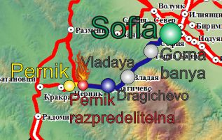
On 04.09.2021, fast train No 7623 arrived from Vidin station at Sofia final destination station at 17:10 p.m. At 19:15 p.m. the train composition was submitted to Nadezhda WD for equipment, cleaning and technical inspection. At 20:30 p.m. after completion of the necessary inspections and equipment in the depot, the composition was handed over for operation. The composition was drawn and composed on the seventh track in Sofia station for passenger train No50215 in Pernik station direction. During the technical inspection and test A of the train in Sofia station, no irregularities were found in the train’s running and electrical equipment. The inspection carried out in Nadezhda WD on the electric lighting of the train did not reveal any irregularities either.
Fig. 3.1. Scheme of the operation route of PT № 50215 with the place of burning of the coach – Pernik marshalling yard.

- Origin station of the train movement;
- Final station, where the train stopped;
- Main stations on the train alignment;
- End destination station for the train movement;
- Place, where the accident occurred;
- Track that the train passed;
- Track that the train did not succeed to pass.
The train departed under schedule from Sofia station at 22:30 p.m. with route Sofia - Vladaya — Pernik marshalling yard — Pernik. The train was operated by electric locomotive No91520044098-9 with locomotive crew — locomotive driver first person and locomotive driver second person. The transport crew consisted of train manager and conductor. A railway undertaking for passenger transport, “BDZ-Passenger Services” Ltd., operated the train. The staff was of the same undertaking. No irregularities were detected in the coaches during the train movement to Pernik station. There were two passengers in the last coach of the train, as one got off at Metal station and the other at Pernik station. The train arrived 23:18:50 p.m. on the fourth main track in Pernik marshalling yard, and after 30 seconds stay, it departed at 23:19:20 p.m. (fig. 4.4). At that moment there were no indications for fire in the fifth last coach № 51522563019-0 of the train. During its departure emergency brake of the train was activated by an unknown person, and the train stopped. The traffic manager on-duty noticed smoke coming out from the last coach No 51522563019-0, the fifth of the train composition. He took a fire extinguisher from the station and went to the coach. When opening, the coach door, he noticed that thick black smoke emerged from the inner part of the coach and found that the coach was burning and did not enter. The train staff notified the single emergency telephone 112 on fire emerged in the passenger train. The voltage was switched off at 23:23 p.m. The passengers were evacuated from the train at a safe distance and the coach was detached from the train composition. The fire in the coach was extinguished at 00:25 a.m. At 00:48 a.m. Test “D” was performed to PT No50215 and the train departed to Pernik station with four coaches.
As a result from the fire occurred in the fifth coach from the composition of PT № 50215 there were no injured passengers and staff, damages were caused to the passenger coach (the compartment was burnt).
The train traffic through Pernik marshalling yard was not interrupted
      - Circumstances prior the accident.
According to the written explanations provided by the conductor of train No 50215, when checking the tickets, he found that there were two passengers in the coach to the halt of Metal, one of them got off the train at the halt, and the other passenger got off the train at Pernik marshalling yard before detecting the fire in the coach by the traffic manager on-duty.
    - Date, punctual time and location of the event.
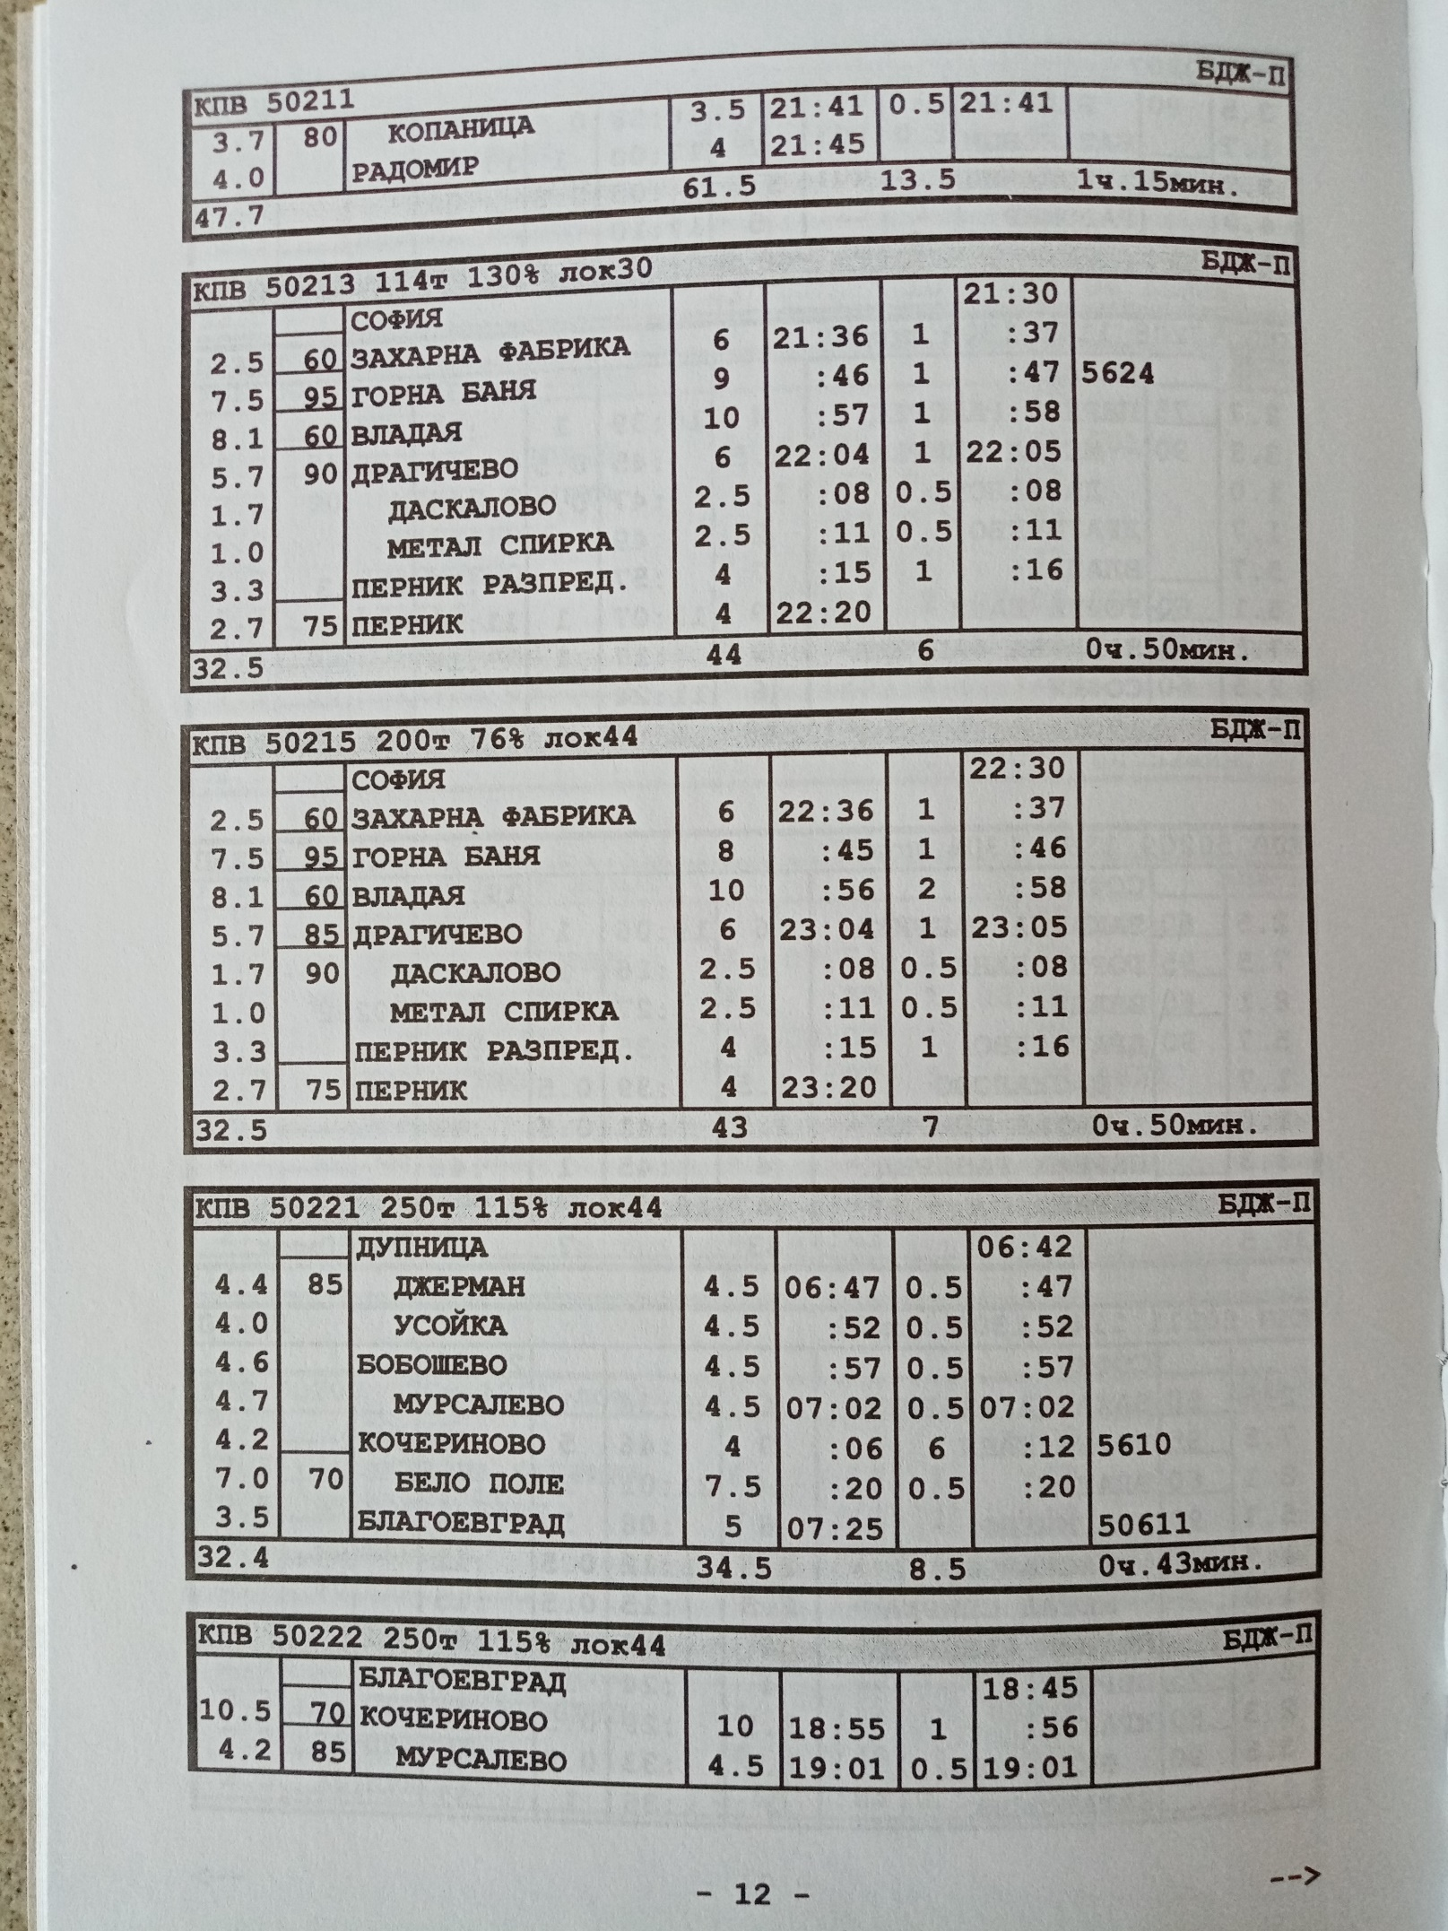
The fire in PT № 50215 was found on 04.09.2021 at 23:19 p.m. during the train departure after an actual stay of 30 seconds in Pernik marshalling yard (fig. 3.2, pos. 1).
Fig. 3.2. Schedule of movement of PT № 50215.
1
    - Description of the event location:
The railway accident occurred on fourth main track in Pernik marshalling yard. The track is in a straight line with profile 0,70 ‰ in downhill (fig. 3.3).
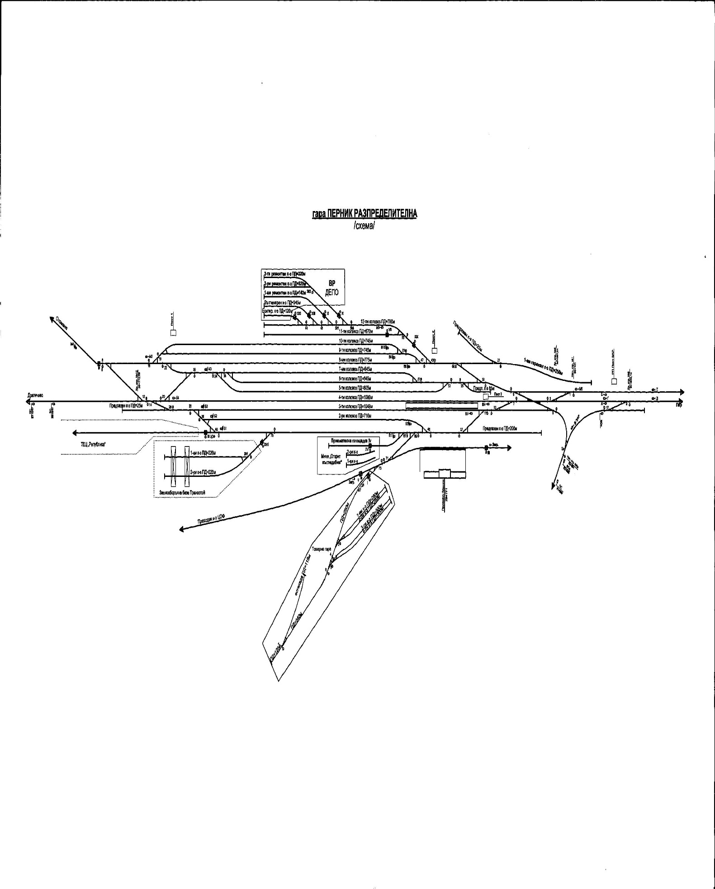
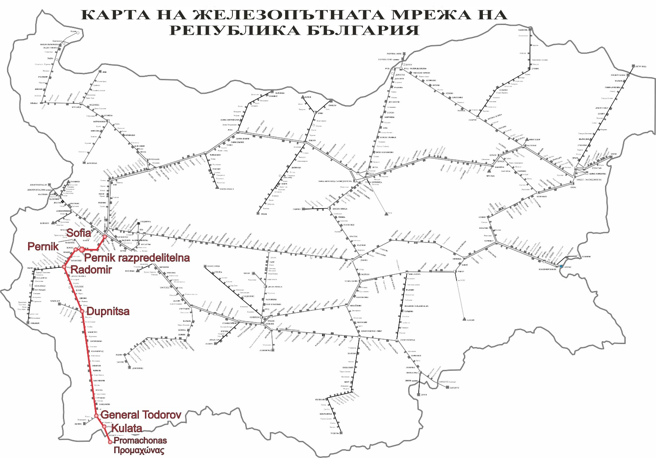
Pernik marshalling yard is located along main railway line № 5. The main railway line №5 is in direction Sofia-Pernik-Radomir-Dupnitsa – Blagoevgrad – Kulata, linking the railway connection with the Hellenic Republic. The railway line is a single-track, electrified, conventional, with traffic speed to 110 km/h (fig. 3.4).
Fig. 3.3. Pernik marshalling yard layout scheme.
Fourth main track in the station
Place of detection of PT № 50215
Train movement
direction
Fig. 3.4. Scheme of the main railway line № 5 with layout of bigger stations.
Map of the railway network of the Republic of Bulgaria

      - Meteorological and geographical condition at the time of the event.
- In the dark part of the day – 23:18 p.m.;
- Air temperature +13ºС;
- Wind speed 8,2 km/h;
- Weather – clear and with normal visibility of the signals;
      - Performance of construction activities on the site or in vicinity.
Not applicable
    - Fatalities, injuries and material damages:
      - Employees of the railway infrastructure manager or railway undertaking.
None.
      - Other persons officially connected with the location of the event.
None.
      - Passengers.
None.
      - External persons.
None.
      - Cargo, luggage or other property.
None.
      - Environment.
None.
      - Rolling stock.
Damages were caused to the burnt coach № 51522563019-0 of PT № 50215;
The railway undertaking for passenger traffic BDZ PS Ltd. provided information on the caused damages amounting to 68 368,05 BGN.;
      - Railway infrastructure.
There were no damages
    - Description of other consequences, including the event impact on the usual activity of the participants.
Not applicable
    - Identity of the participants and their functions.
      - Railway infrastructure:
- SE National railway infrastructure company has Safety Authorization № BG 21/2018/0001 valid from 01.07.2018 until 30.06.2023.
SE NRIC personnel, involved in the accident:
- Traffic manager on-duty in Pernik marshalling yard;
      - Railway undertaking:
- „BDZ-Passenger services“ Ltd. has:
    - License for performing railway transport services № 203/31.12.2018;
    - Safety certificate part А BG 11 2017 0008, valid to 30.12.2022;
    - Safety certificate part B BG 12 2017 0008, valid to 30.12.2022.
The personnel of BDZ PS Ltd. involved in the accident:
- Locomotive driver I-st person of locomotive № 91520044098-9;
- Locomotive driver II-nd person of locomotive № 91520044098-9.
    - Description of the respective parts of the railway infrastructure and signalling system:
      - Type of the track, railway switch, rail crossing etc.
Fourth track in Pernik marshalling yard is a main acceptance-departure track for passenger traffic with inclination 0,70 ‰ in downhill;
      - Interstation block system, station installation, type of signalling.
The interstation Dragichevo-Pernik marshalling yard is equipped with semi-automatic block system (SABS);
Pernik marshalling yard is equipped with station signalling type Electrical-mechanic interlocking (EMI);
      - Train protection systems.
There is no train protection system along the main railway line № 5. Pernik marshalling yard is equipped with train dispatching radio connection (TDRC), by which means the locomotive driver performs radio connection with the train dispatcher and traffic manager on-duty in the single stations, with the trains along the respective section. The ingoing and outgoing messages are realized by communication device (UCAS-8).
Locomotive № 91520044098-9 is equipped with registering speedometer type „Hasler“ RT9, and non-registering speedometer type „Hasler“ А16, and warning device active type.
    - Other information referring the event.
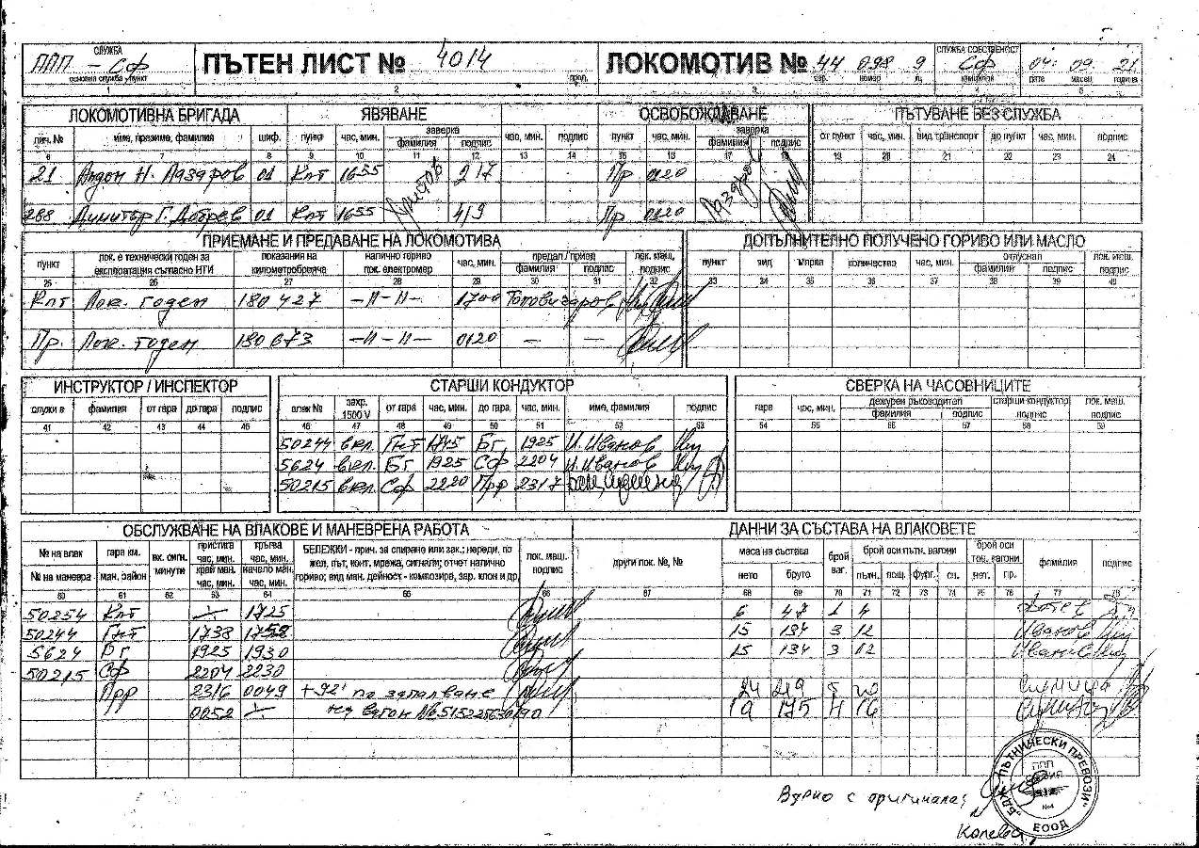
The train documents „Way-bill“ (fig. 3.5 and 3.6), ,,Accompanying sheet“ (fig. 3.7), „Nature sheet“ (fig. 3.8) and „Authorization for brake mass“ (fig. 3.9) corresponding to the hours of the actual movement of PT № 50215 according to the data that SE NRIC has presented and the speedometer tape of locomotive № 91520044098-9 that has been processed in a punctual and correct manner.
Fig. 3.5. Way-bill of PT № 50215 – front part.

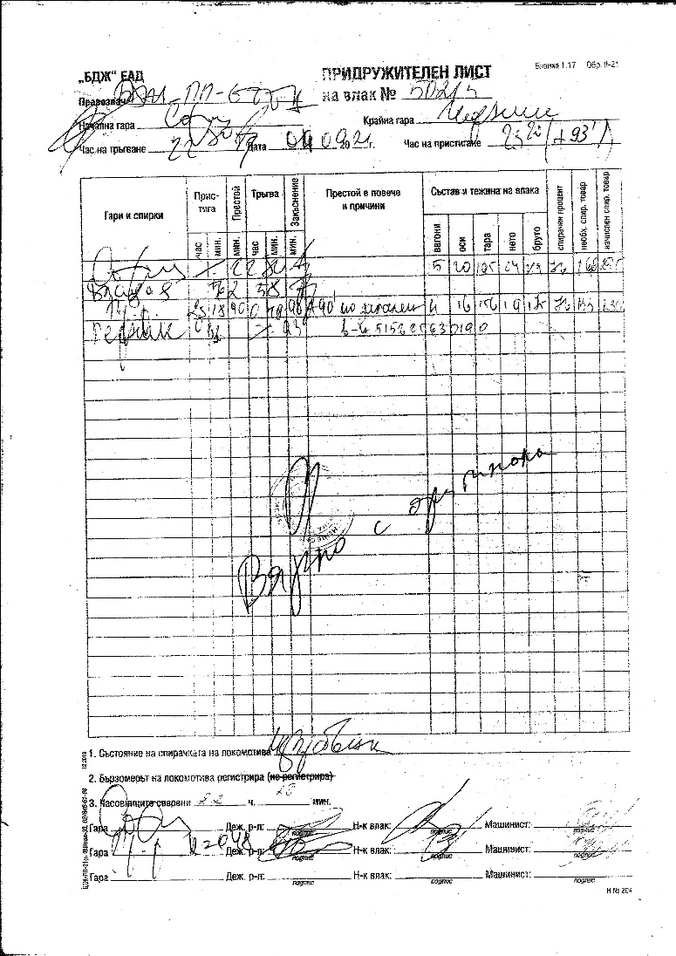
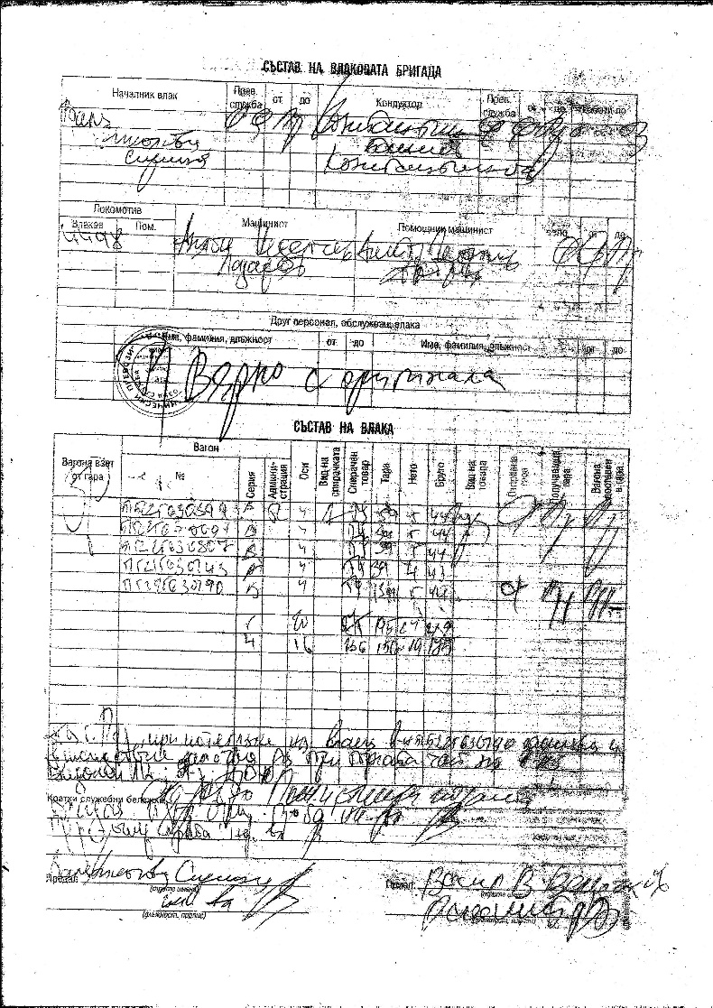
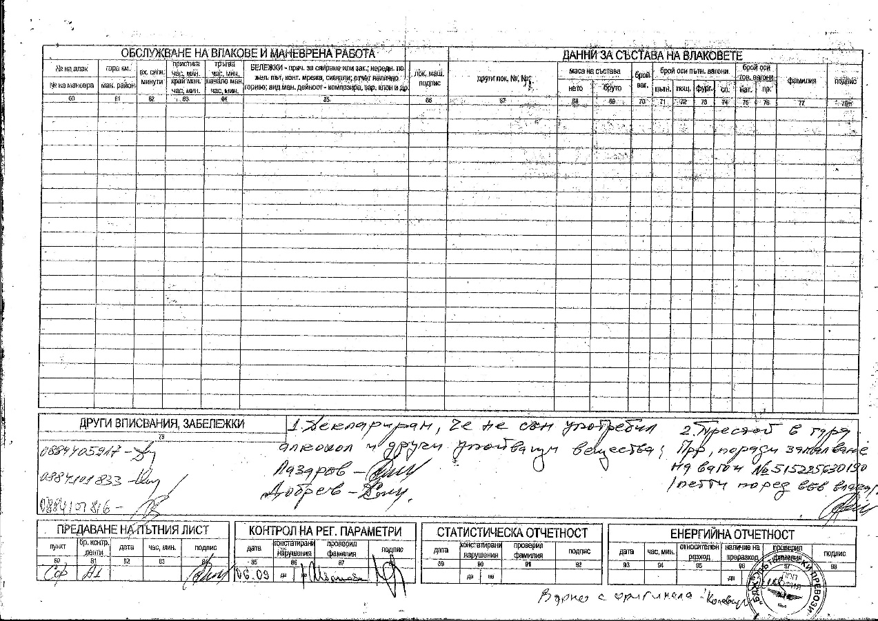
Fig. 3.7. Accompanying sheet of PT № 50215.
Fig. 3.6. Way-bill of PT № 50215 – back part.

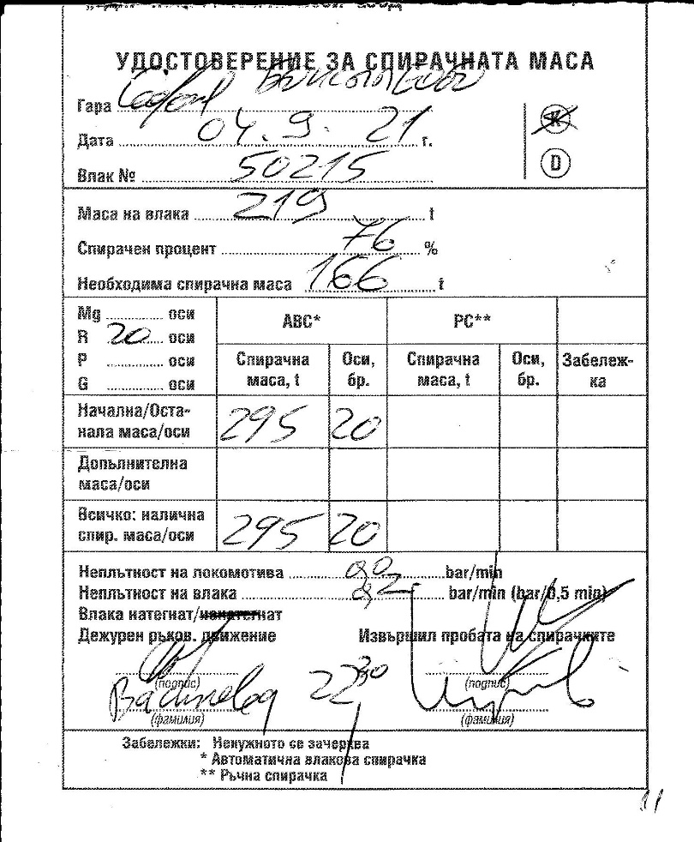
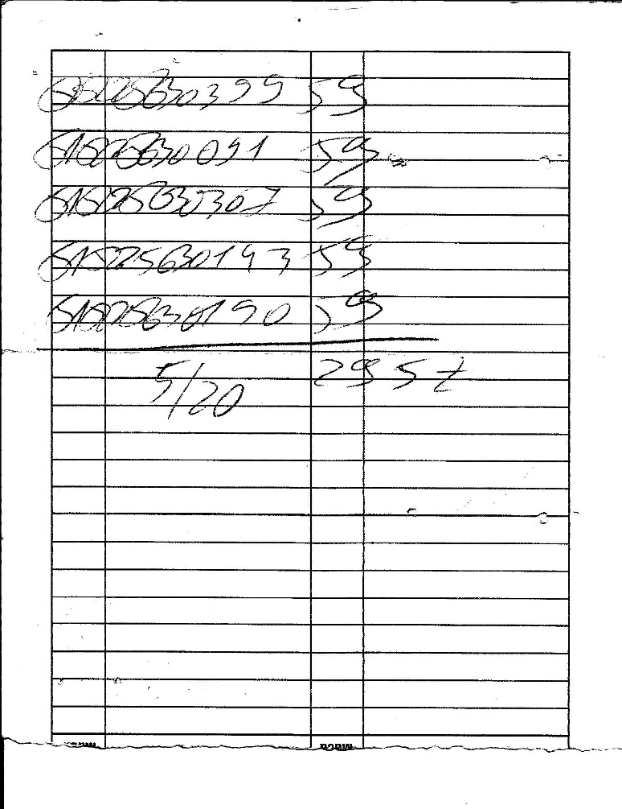
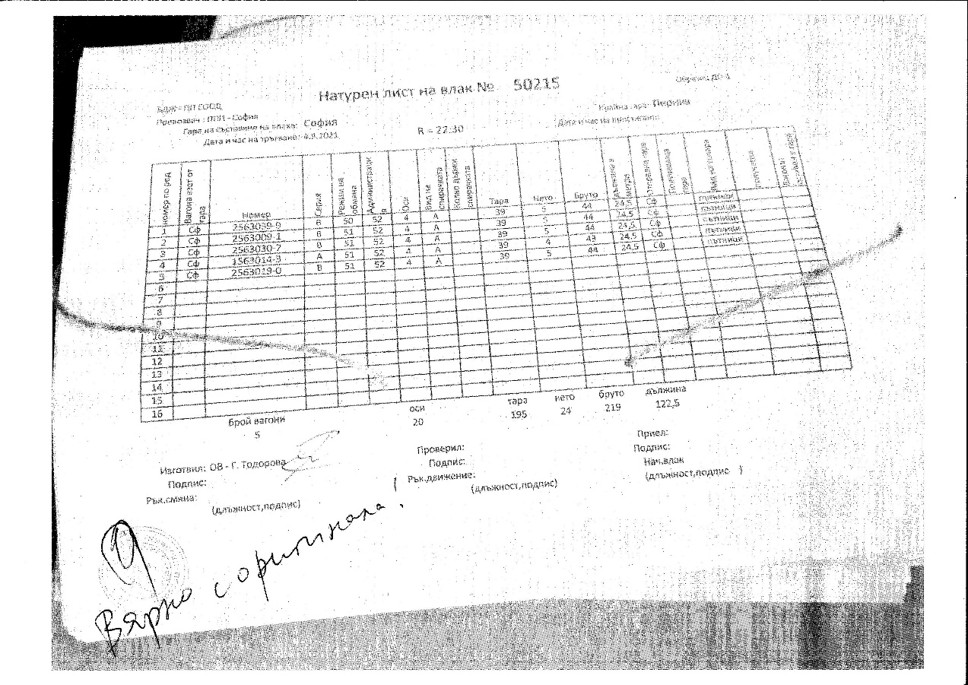
Fig. 3.9. Authorization for brake mass of PT № 50215.
Fig. 3.8. Nature sheet of PT ПВ № 50215.

  - Factual description of the occurred.
    - Immediate sequence of events that led to the accident, including:
      - Actions that the involved in the event persons undertook.
At 23:18 p.m. PT No 50215 was accepted at Pernik station at the 4th main track with a scheduled stop. After a stay of 30 seconds and an authorised indication of the exit semaphore and an order to depart from the traffic manager on-duty, the train departed and stopped after 10-15 metres. The investigation revealed that the emergency brake was activated by a passenger in the fifth coach (Figure 3.10).
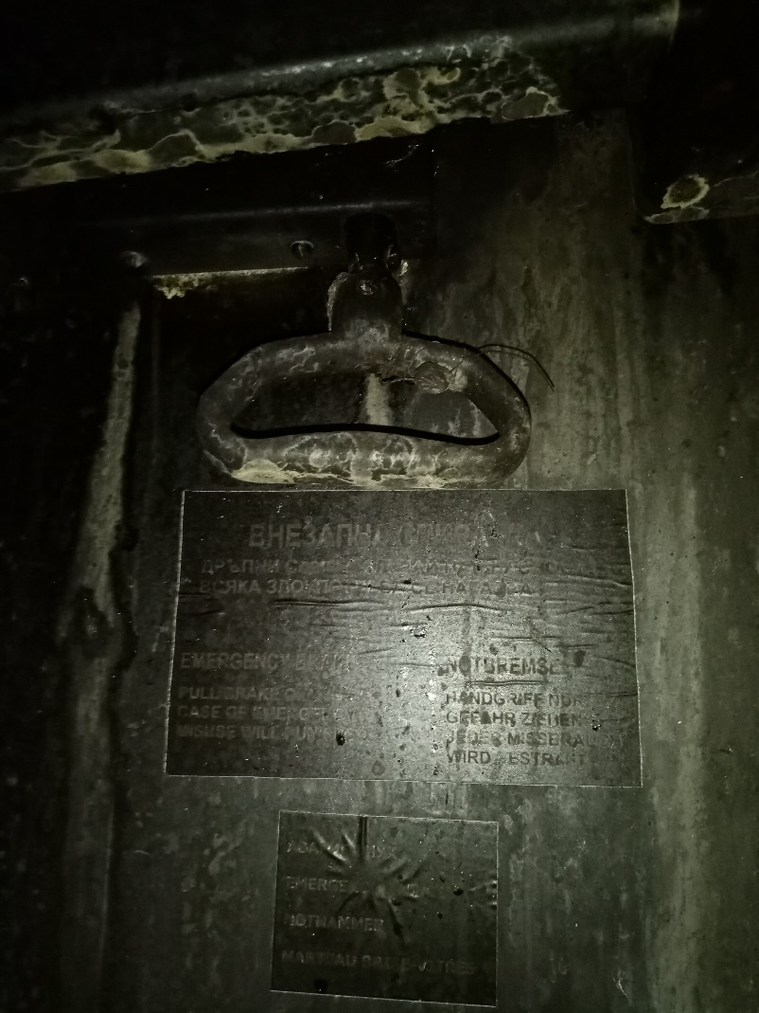
The traffic manager on-duty on the platform saw smoke coming out of the fifth, last coach (Figure 3.11). He went back to the station, picked up a fire extinguisher and headed to the fifth coach. He opened the coach door and there started to come out thick black smoke, he noticed that the coach was burning from the inside and returned. The head of the train and the conductor evacuated the passengers out of the train. The locomotive crew detached the burning coach from the train composition and withdrew the train at a safe distance. The train staff notified the 112 emergency phone on a fire in the passenger train. The voltage in the catenary was switched off at 23:23 p.m. After arriving at 23:40 p.m. of a special vehicle of FSaCP-Pernik, the fire in the coach was extinguished at 00:20 a.m. The voltage at the station was switched on at 00:48 a.m. Test D was carried out on PT No 50215 and it departed at 00:48 a.m. with four coaches to Pernik station, final destination station for the train.
Fig. 3.10. Activated emergency brake in the rear part of the coach №51522563019-0.
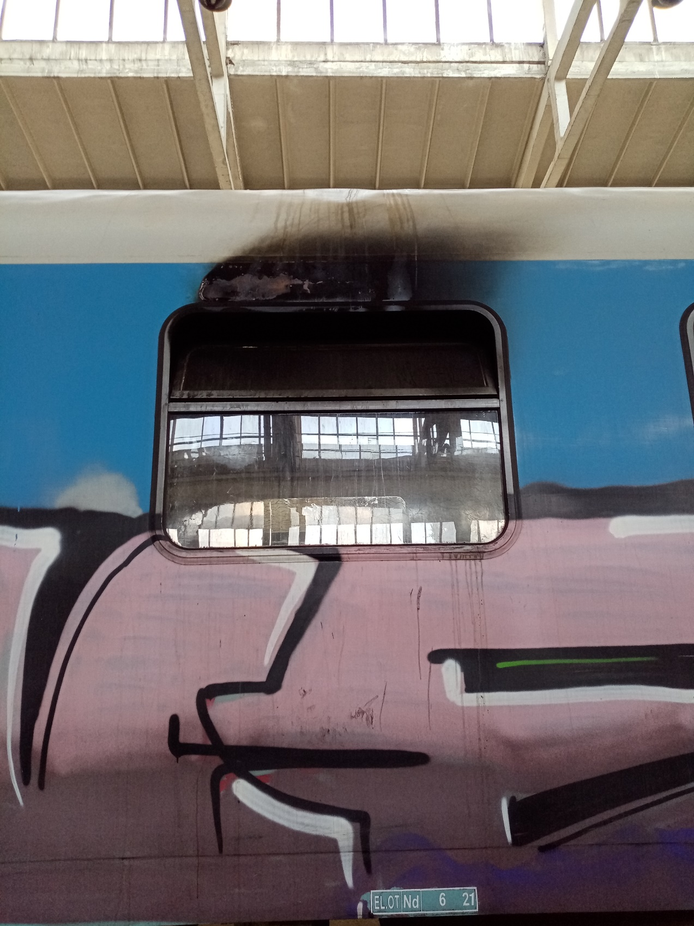
,,BDZ-Passenger Services“ Ltd. transported back individually the burnt coach by locomotive № 97520061012-2 to Nadezhda WD around 04:00 a.m. on 05.09.2021 for performing subsequent actions on the investigation.
Fig. 3.11. Traces from the ignition of coach № 51522563019-0 from its outer part.
      - Rolling stock and technical facilities functioning.
Until the moment of the accident, the rolling stock is regular and functions normally.
      - Operational system functioning.
The operational system is regular with proper functions before and after the accident.
    - Sequence of events from the beginning of the accident to the end of the rescue services actions:
At 23:19 p.m., a fire was detected in coach No 51522563019-0, fifth from the composition of PT No 50215 while departing from Pernik marshalling yard. The authorities of FSaCP were notified by the emergency phone calls number 112. After the FSaCP arrival and suppression of the fire at 00:20 a.m., the train departed with four coaches at 00:48 a.m. to Pernik station.
      - Undertaken measures for protecting and guarding the event location.
Not applicable.
      - Actions of the emergency rescue services.
Not applicable.
      - Actions of the emergency rehabilitation services.
Not applicable.

- Analysis of the event
  - Participation and responsibilities of the entities, involved in the event:
    - Railway undertaking.
      - Analysis of the train movement.
The analysis of the movement of PT No 50215 was carried out from the moment of his arrival in Dragichevo station until the moment of the emergency stop at Pernik marshalling yard, due to the occurred fire. It should be noted that due to the displacement of the nibs recording the time and pressure in the main air-duct compared to that recording the speed of movement, they are marked in the graph with two straight vertical dotted lines: yellow for speed registrations (Figure 4.1, position 1) and dark blue for time recording (Figure 4.1, pos. 2), with the two lines jointly taking into account the same moment recorded by the two nibs.
Yellow horizontal lines further explain the speed values marked at ten km/h with their numerical values, and there are thinner lines specifying the values at 2 km/h (Figure 4.1, pos. 3).
The time recording area additionally displays light blue horizontal lines specifying the minutes of the events, as the first, fifth and tenth lines being thicker and with additional numerical values, and thinner lines each denoting ten seconds in the minute (Figure 4.1. pos.4). This allows the time to be calculated with an accuracy of up to 10 seconds. All this has been done for better transparency and clarity when carrying out the analysis.
PT No 50215 arrives at Dragichevo station (Figure 4.1, pos. 5) at 23:09:00 p.m., and after a stay of 30 seconds departs at 23:09:30 p.m. (Fig. 4.1, pos. 6). Develops maximum speed 63 km/h (Fig. 4.1, pos. 7) when the allowed for Vladya - Pernik section is 90 km/h, then reduces the speed, holding twice with the automatic train brake, venting air from the main air-duct and at 23:11:20 p.m. settles at Daskalovo halt (Figure 4.2, position. 1). After a stay of 1 minute, departs at 23:12:20 p.m. (Figure 4.2, pos. 2). While travelling to Metal halt, it develops a maximum speed of 60 km/h (Fig. 4.2, pos. 3) and arrives at the halt at 23:14:00 p.m. (Fig. 4.3, pos. 1). It stays 30 seconds and departs at 23:14:30 p.m.
After departure from Metal halt, the train accelerates and again develops speed up to 63 km/h (Fig. 4.4, pos. 1), after which the speed starts to decrease gradually to 47 km/h due to the locomotive driver holding with the automatic train brake, reducing the pressure in the main air duct from 5 to 4 bar, then loosening the brake, the speed increases to 50 km/h, again the driver holds with the train brake, the speed decreases to 48 km/h, there is a new increase in speed to 50 km/h due to a new loosening of the brake, after which the speed begins to decrease again due to multiple retention with the automatic brake until finally the speed decreases to 0 km/h and the train settles at Pernik marshalling yard at 23:18:50 p.m. (Figure 4.4, pos. 2). The train stays for 30 seconds at the station (Figure 4.4, pos. 3).
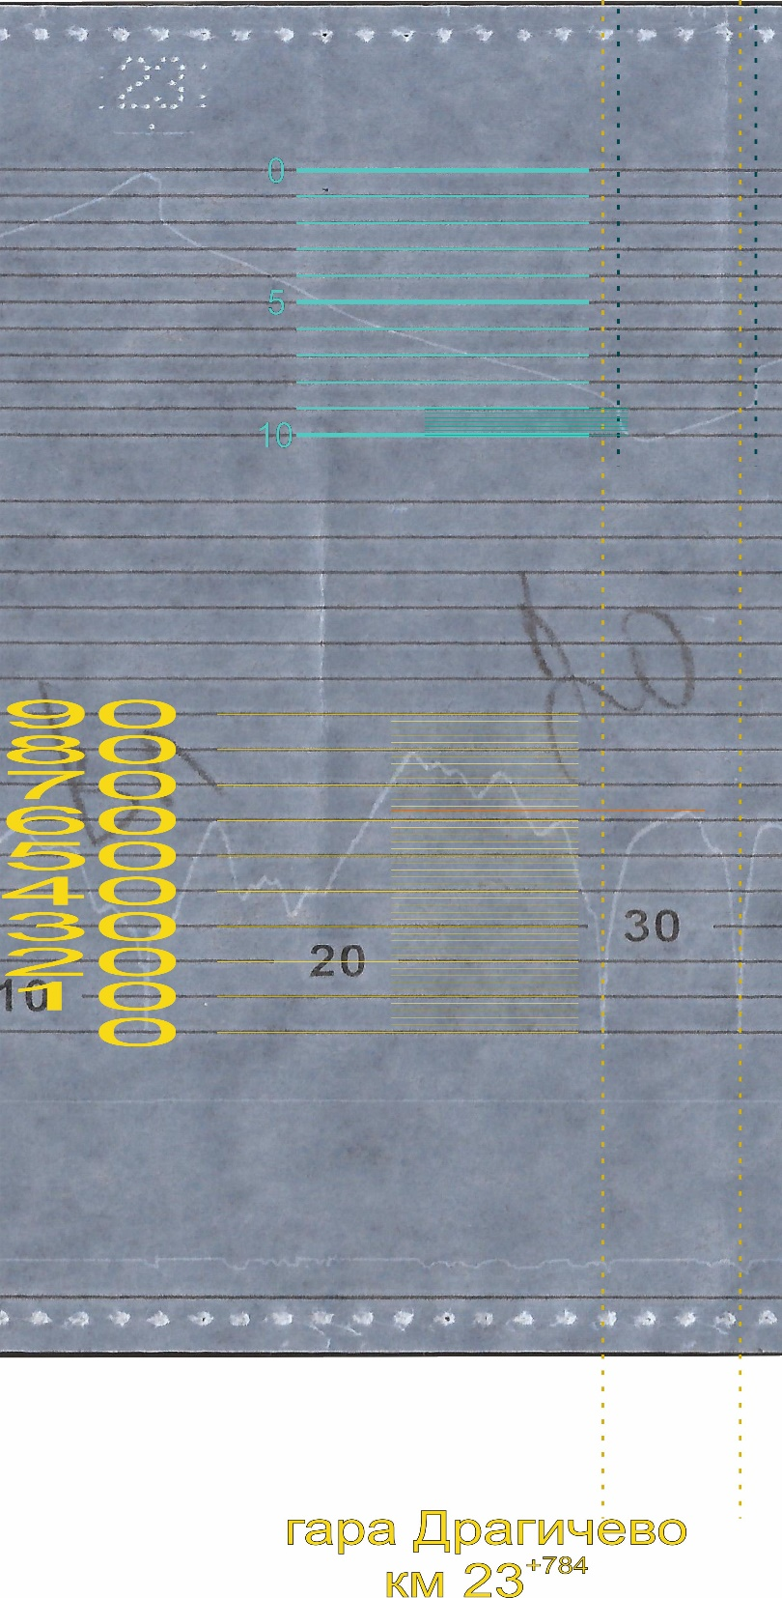
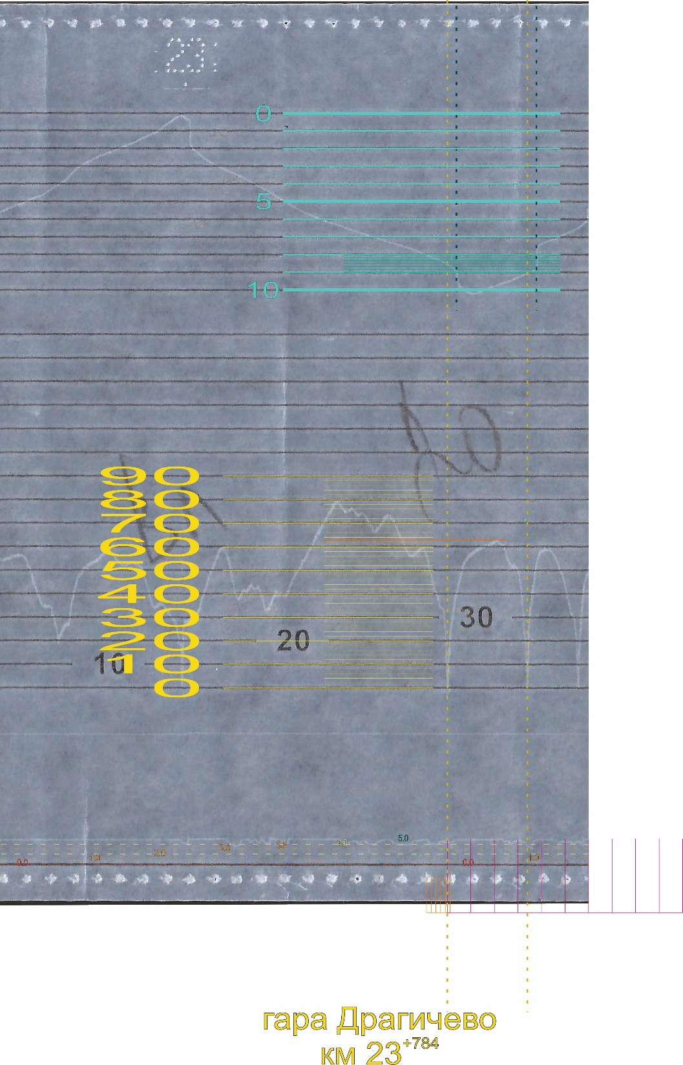
Train № 50215 departs at 23:19:20 p.m., it develops speed to 15 km/h, passes 15-20 meters for around 10 seconds, and then stops sharply at 23:19:30 p.m. because of the activation of automatic train brake in a “fast stop’ mode (fig. 4.4, pos. 4).
Fig. 4.1. Decoding of the train movement from the arrival at Dragichevo station to the stopping at Daskalovo halt.
3
4
2
1
5
6
7
Fig. 4.2. Decoding of the train movement from the arrival at Daskalovo halt to the departure to Metal halt.
2
1
3
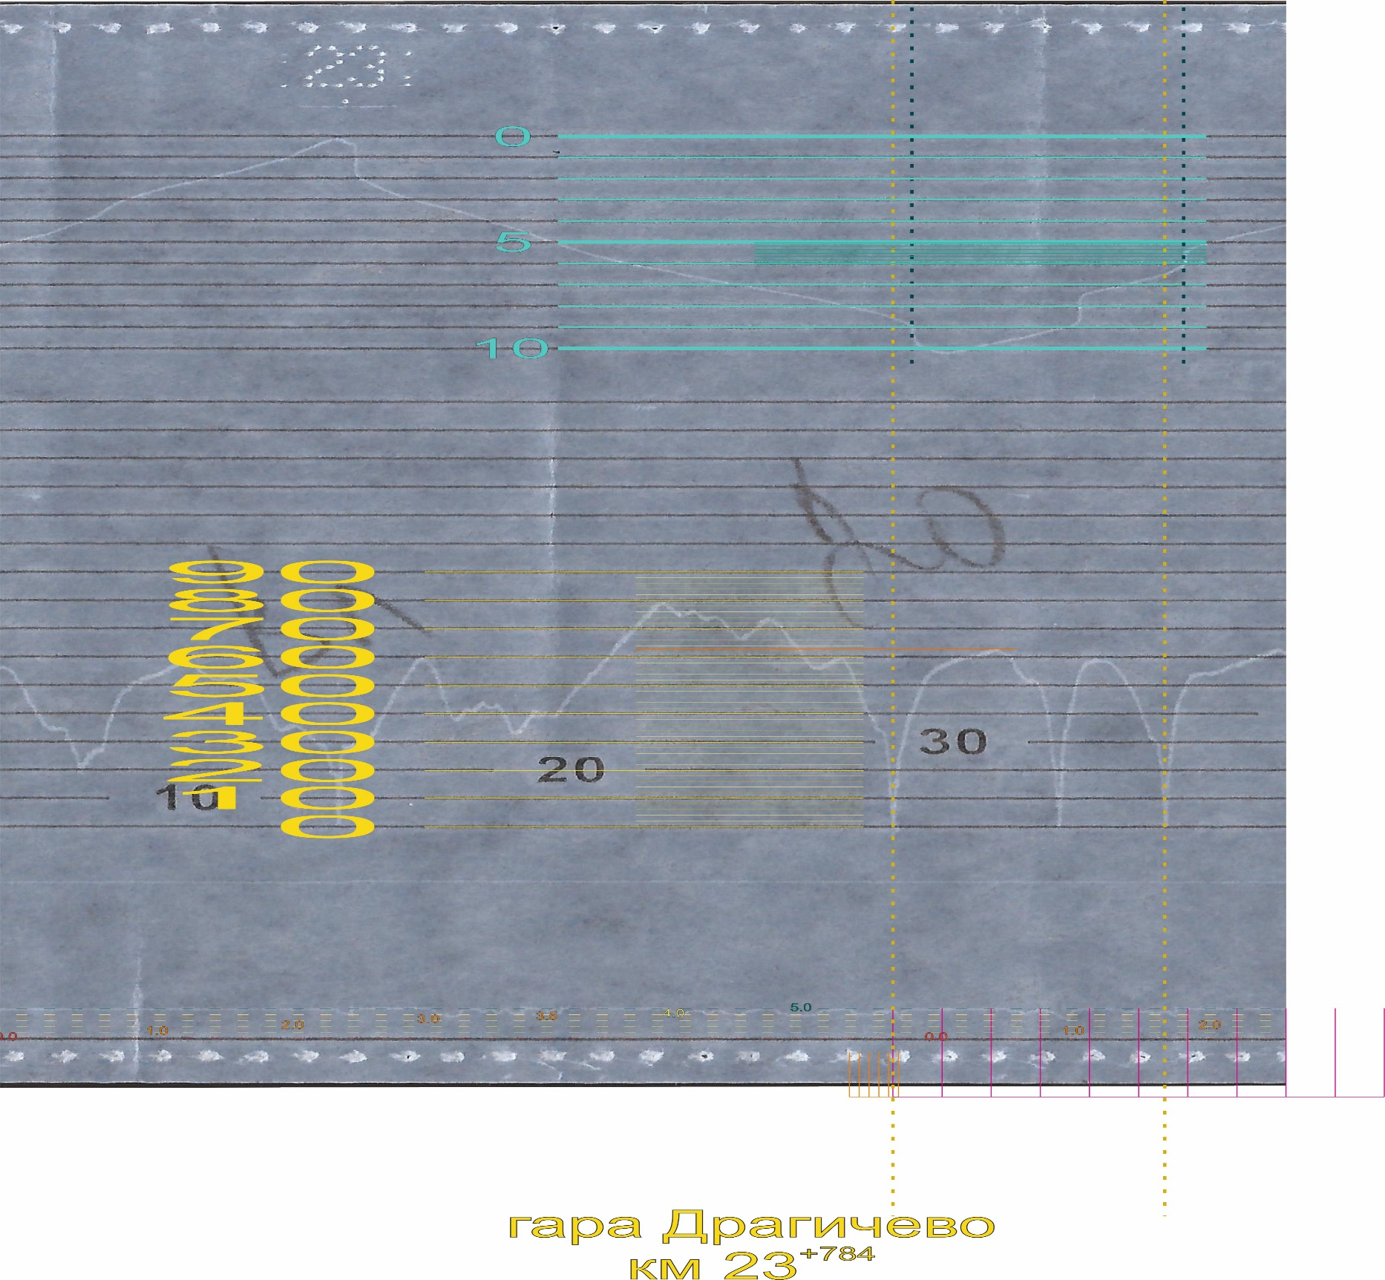
Fig. 4.3. Decoding of the train movement from the arrival at Metal halt to the departure for Pernik marshalling yard.
1

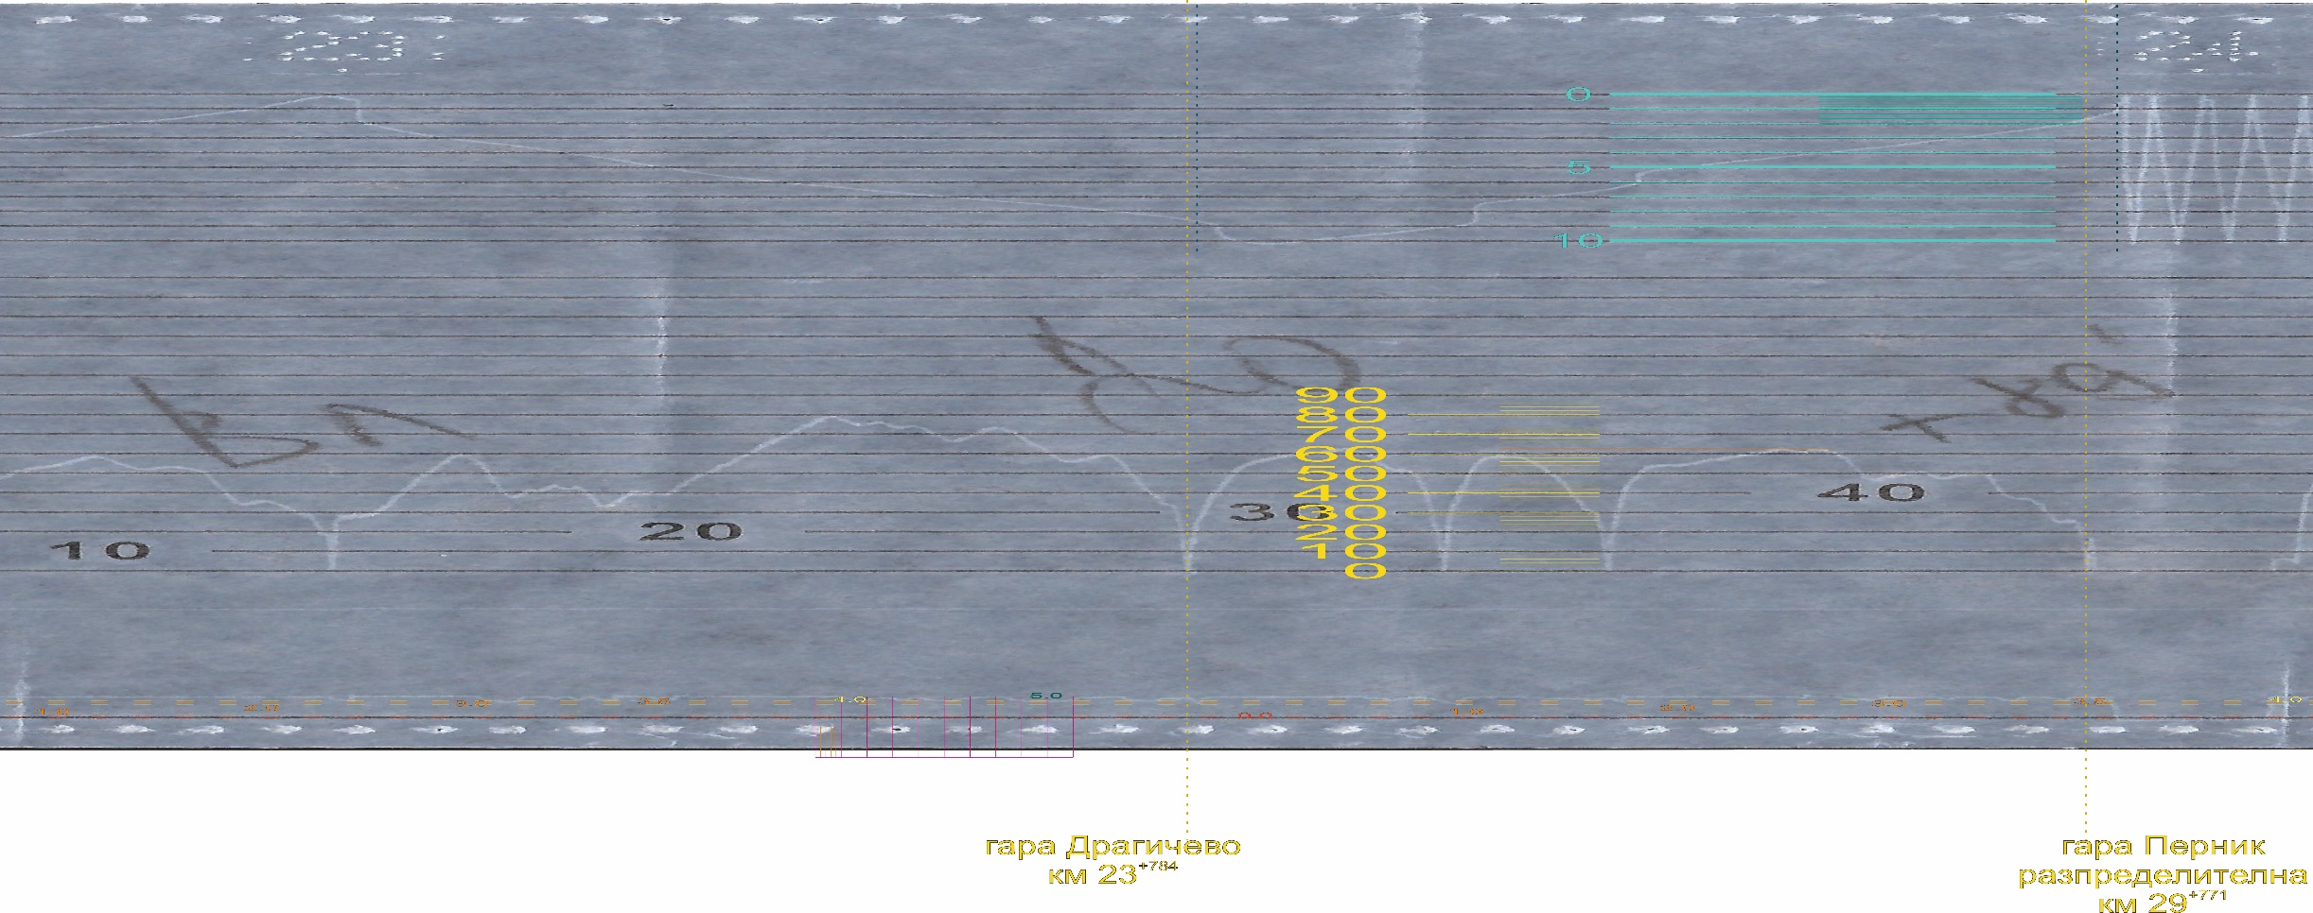
      - Analysis of the ignition of coach № 51522563019-0.
Fig. 4.4. Decoding of the train movement from the departure from Metal halt to the detection of the fire in coach № 51522563019-0 during its departure to Pernik marshalling yard.
1
2
3
4
The Investigation Commission carried out several detailed inspections of the burnt coach in Nadezhda WD. During the inspections were examined, discussed and analysed all possible hypotheses for the occurrence of the fire.
As an initial hypothesis, the possibility of ignition from a flammable liquid was discussed and analysed: alcohol or other similar substance. At first, it seemed reliable enough, but after a more detailed inspection of the ignition site, it was considered unlikely. The reason for this assessment was the presence of an extremely high temperature in the baggage compartment area, concentrated in a limited small area (Figure 4.5, pos. 1). The ignition of the upholstery of the seats in the fire area was obvious, but with such a development of fire it would spread upwards over a much larger area and hardly the temperature of the fire would have reached such values and certainly not in such a small area as to melt and bend the aluminium skeletons of the luggage compartments, burning at the same time all the elements and wires from the electrical equipment of the coach located there.
The second hypothesis, examined and analysed in depth by the Investigation Commission, involved failures in the electrical equipment of the coach related to its design and performance. This hypothesis was considered in connection with the extremely high temperature (above 700-800 C) which occurred in the fireplace, resulting in the melting of the aluminium profiles of the baggage compartments, the complete combustion and charring of the insulation of the wires and the structural and colour change of the copper wires themselves (Figure 4.6).

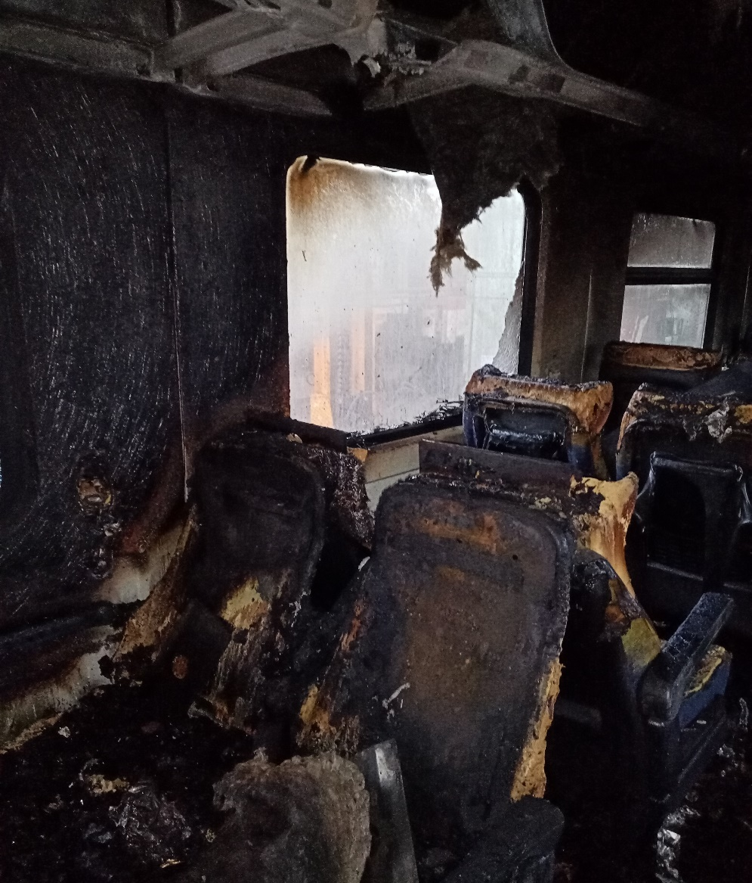
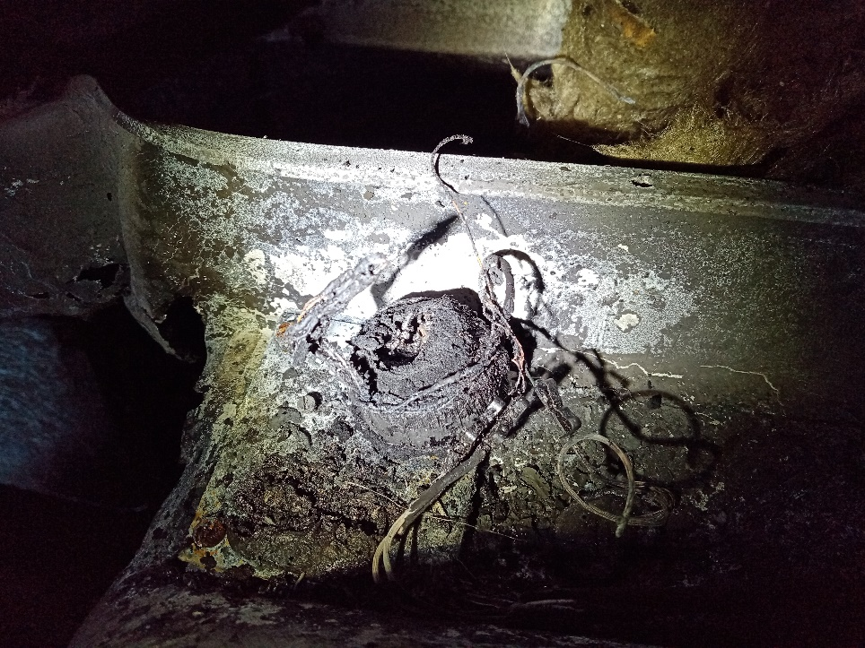
Fig. 4.5. Location of the most intensive burning in the coach compartment.
1
Fig. 4.6. Burnt elements of the electrical equipment of the coach, located in the cavities of the luggage compartment skeleton.
In the analysis of that hypothesis, the Investigation Commission came to the following conclusions:
- From the point of view of the theory and operational practice, given the minimum current values, it is not possible the ignition of the couch to be caused by a short circuit or overheating of cable connections of the lighting installation or sound installations of the passenger coach;
- The lighting installation is low-voltage (no booster inverters but operates with the battery voltage of the coach) and uses LED lighting elements whose power (i.e. current) is many times lower than similar lighting fixtures of older generation. It is protected by automatic fuses (after the fire, it has been found that no automatic guard switched off);
- The sound installation, at the part of the final amplifier step (located in a cabinet at the beginning of one of the corridors of the coach), has minimum sound power, contains low-power matching transformers for each loudspeaker, is protected by fuses (the Commission found that the fuses of the terminal amplifier stage 6,3A was not “burnt”), i.e. categorically the ignition of the coach cannot be caused by this system.
- Cable harnesses immediately passing to the fire zone are also located in a circuit for extremely low-power AC contacts 220 V (for the inclusion of standard chargers for mobile phones, etc.). It can be stated with confidence that this electric circuit of the coach cannot cause its ignition either;
- The ignited coach No 51522563019-0 is not equipped with the so-called sub-coach generator, and its electrical system is powered by the AC 1500 V train heating circuit. The system for the conversion (lowering and straightening) of this supply voltage is structurally located in cabinets under the coach and there were no traces of short circuits or other accidents and failures in the viewpoints. And this is the system with the highest voltage and therefore the most likely to occur potential ignition hazards;
- During the examinations of the burnt elements and wires, no traces of short circuits were found anywhere - the characteristic “melters” and traces of “welding” of the metals due to the presence of large currents that would give rise to high temperatures;
- On the basis of the above considerations, it can be concluded that the probability of any failure in the electrical circuits of coach No 51522563019-0 being the cause of the fire in the coach is minimal.
The third hypothesis, considered and analysed by the Investigation Commission, allows the fire to be caused by an external source, whether intentionally or inadvertently. In this case, the possibility of starting from an external source (most likely a lighter) imported to the loudspeaker of the sound system shall be considered. It is known that its membrane is made of impregnated paper and the remaining parts, with the coil of the matching transformer also made of combustible materials. All of this, with a very high probability, could be ignited by the imported fire, then further combusted, developing extremely high temperatures, and molten aluminium would immerse on the seat upholstery and trigger their ignition. The fact that the ignition was detected by the traffic manager on-duty at 23:19 p.m., and the authorities of the FSaCP started the extinguishing only after 23:40 p.m. shows that the fire had sufficient time to burn and cause damage to the coach. Ultimately, it can be stated that the hypothesis described is the most likely to cause the fire in coach No 51522563019-0.
The Investigation Commission considers that this is also the most likely cause of the fire.
    - Manager of the railway infrastructure.
Not applicable
    - Entities in charge of the technical maintenance.
Entity in charge of the rolling stock maintenance – locomotive № 91520044098-9 and of coach № 51522563019-0 is BDZ PS Ltd. with valid registration in the National vehicles register.
    - Manufacturers or providers of rolling stock and railway products.
Not applicable.
    - National Safety Authority.
Railway Administration Executive Agency is the National Safety Authority for railway transport in the Republic of Bulgaria.
    - Notified bodies or Risk assessment bodies.
Not applicable.
    - Certifying bodies of the entities in charge of maintenance.
The Railway Administration Executive Agency as the National Safety Authority for railway transport performs certification of the entities in charge of the vehicles maintenance (ECM) in accordance with Directive 2004/49/EC and Regulation (EU) 445/2011, as per Ordinance No 59 on the railway transport safety management and on the maintenance functions in accordance with Directive 2004/49/EC and Regulation (EU) 445/2011.
From June 16, 2020 the RAEA performs certification of the ECM as per the Commission Implementing Regulation (EU) 2019/779 of 16 May 2019 laying down detailed provisions on a system of certification of entities in charge of maintenance of vehicles pursuant to Directive (EU) 2016/798 of the European Parliament and of the Council and repealing Commission Regulation (EU) No 445/2011.
    - Persons or entities involved in the event, documented or not in the respective safety management systems or indicated in register.
Not applicable.
  - Rolling stock and technical facilities:
    - Factors, deriving from the design of the rolling stock, railway infrastructure or technical facilities.
Not applicable.
    - Factors deriving from the installation and placing into service of the rolling stock, railway infrastructure and technical facilities.
Not applicable.
    - Factors deriving from manufacturers or another provider of railway products.
Not applicable.
    - Factors, deriving from the technical maintenance and/or modification of the rolling stock or the technical facilities.
Not applicable.
    - Factors due to the entity in charge of the technical maintenance, workshops for technical maintenance and other technical maintenance service providers.
Not applicable.
    - Other factors or consequences considered as involved within the investigation objectives.
      - Loading of the coaches
Not applicable.
  - Human factor:
    - Individual human characteristics:
      - Training and development, including skills and experience.
Railway undertaking:
• Locomotive driver – I-st person of locomotive № 91520044098-9 – License № 138 for obtaining professional qualification „Locomotive driver of electric locomotives“, training performed within the period 18.05.÷15.08.1998 issued by Professional Training Centre (PTC) of Bulgarian State Railways (BDZ);
Locomotive driving license BG 71 2021 0011 issued by RAEA;
License № 190 of position Locomotive driver and train activity at PSD – Sofia dated 06.12.2017.
• Locomotive driver II-nd person of locomotive № 91520044098-9 – Authorization № 6634-427 for obtaining professional qualification „Locomotive driver of electric locomotives series 43, 44 and 45“, training performed within the period 01.02. ÷ 30.06.2010 issued by Professional Training Centre (PTC) of Bulgarian State Railways (BDZ).
Locomotive driving license BG 71 2017 1000 issued by RAEA;
License № 698 of position Locomotive driver and train activity at PSD – Sofia dated 02.04.2018.
Railway infrastructure:
• Traffic manager in Pernik marshalling yard – Certificate of qualification № 1027 for, Traffic manager“, training performed within the period 26.05.÷08.12.2008 issued by the Professional Training Centre at NRIC;
Certificate № 2269 for position Traffic manager at TOSAD – Sofia from 07.08.2009.
      - Medical and personal circumstances, which influence the event, including the presence of physical and psychological stress.
Railway undertaking:
• Locomotive driver I-st person of locomotive № 91520044098-9:
Single-health dossier № 863 for periodical medical exam dated 11.03.2021, issued by Sofia Multi-profile Transport Hospital:
Conclusion: suitable for locomotive driver.
Physiological exam № 1601/19.11.2020, issued by Laboratory for physiological expertise at Sofia Multi-profile Transport Hospital for locomotive driver. Conclusion: accepted for a 3-year period.
• Locomotive driver II-nd person of locomotive № 91520044098-9:
Single-health dossier № 482 for periodical medical exam dated 11.03.2021, issued by Sofia Multi-profile Transport Hospital:
Conclusion: suitable for locomotive driver.
Physiological exam № 1356/06.10.2017, issued by Laboratory for physiological expertise at Sofia Multi-profile Transport Hospital for locomotive driver. Conclusion: accepted for a 5-year period.
Railway infrastructure:
• Traffic manager in Pernik marshalling yard:
Single health dossier № 1227 for periodical medical exams dated 18.05.2021, issued by Sofia Multi-profile Transport Hospital, conclusion – suitable for traffic manager.
Physiological exam № 449/06.04.2021, issued by Laboratory for physiological expertise at Sofia Multi-profile Transport Hospital for traffic manager.
Conclusion: accepted for a one-year period.
      - Fatigue.
Railway undertaking:
• Locomotive driver I-st person of locomotive № 91520044098-9:
Break/rest: from 19:35 p.m. on 03.09.2021 until 16:35 p.m. on 04.09.2021(21 hours and 00 minutes);
• Locomotive driver II-nd person of locomotive № 91520044098-9:
Break/rest: from 19:35 p.m. on 03.09.2021 until 16:35 p.m. on 04.09.2021. (21 hours and 00 minutes);
Railway infrastructure:
• Traffic manager in Pernik marshalling yard:
Break/rest: from 18:40 p.m. on 03.09.2021 until 18:40 p.m. on 04.09.2021 (24 hours and 00 minutes);
      - Motivation and attitudes.
Not applicable.
    - Work related factors:
      - Tasks planning.
BDZ PS Ltd. carries out passenger transport under the Train Composing Plan, which are implemented according to an approved Train Movement Schedule by the Railway Infrastructure Manager (SE NRIC).
      - Constructive particularities of the facilities that influence the connection human-machine.
Not applicable.
      - Communication means.
Not applicable.
      - Practices and processes.
Not applicable.
      - Operation rules, local instructions, staff requirements, prescriptions for technical maintenance and applicable standards.
Application of the national normative acts and internal standards.
      - Working time of the involved personnel.
In accordance with the requirements of the normative acts - Labour Code and Ordinance № 50 of 28.12.2001 for the working hours of the managerial and executive staff, engaged in providing the transportation of passengers and freights in the railway transport. The staff of both entities works in shifts/suspension (when servicing a train or a vehicle - with a variable start and different working hours), in which a summary calculation of the working time shift in a 12-hour work shift and full working month are applied.
      - Risk treatment practices.
SE NRIC applies safety procedure SP 2.09 „Methods of evaluation, assessment and management of the risk „version 05 effective from 01.03.2019, which is part of the SMS.
BDZ-PS Ltd. applies the procedure “Methodology for risk analysis and assessment in BDZ-PS” in force since 2013 part of the SMS.
    - Context, machinery, equipment and indications for shaping the working practices
Not applicable.
    - Organizational factors and tasks:
      - Planning of the working force and the working load.
As per the requirements of the normative documents and best practices.
      - Communications, information and teamwork.
Not applicable.
      - Recruitment, staffing requirements, resources.
Not applicable.
      - Implementation management and supervision.
Not applicable.
      - Compensation (remuneration).
Not applicable.
      - Leadership, powers related issues.
Not applicable.
      - Organizational culture.
Not applicable.
      - Legal issues (including the respective European and national rules and provisions).
Not applicable.
      - Regulatory framework conditions and safety management system application.
Railway undertaking.
- Directive (EU) 2016/798 of the European Parliament and of the Council of 11 May 2016 on railway safety;
- Commission Delegated Regulation (EU) 2018/762 of 8 March 2018 establishing common safety methods on safety management system requirements pursuant to Directive (EU) 2016/798 of the European Parliament and of the Council and repealing Commission Regulations (EU) No 1158/2010 and (EU) No 1169/2010;
- COMMISSION IMPLEMENTING REGULATION (EU) 2019/779 of 16 May 2019 laying down detailed provisions on a system of certification of entities in charge of maintenance of vehicles pursuant to Directive (EU) 2016/798 of the European Parliament and of the Council and repealing Commission Regulation (EU) No 445/2011;
- COMMISSION IMPLEMENTING REGULATION (EU) No 402/2013 of 30 April 2013 on the common safety method for risk evaluation and assessment and repealing Regulation (EC) No 352/2009;
- Railway Transport Act;
- ORDINANCE No 59 dated 5.12.2006 on the railway transport safety management.
- TOR and TOSAR.
Railway infrastructure.
- Directive (EU) 2016/798 of the European Parliament and of the Council of 11 May 2016 on railway safety;
- Commission Delegated Regulation (EU) 2018/762 of 8 March 2018 establishing common safety methods on safety management system requirements pursuant to Directive (EU) 2016/798 of the European Parliament and of the Council and repealing Commission Regulations (EU) No 1158/2010 and (EU) No 1169/2010;
- COMMISSION IMPLEMENTING REGULATION (EU) 2019/779 of 16 May 2019 laying down detailed provisions on a system of certification of entities in charge of maintenance of vehicles pursuant to Directive (EU) 2016/798 of the European Parliament and of the Council and repealing Commission Regulation (EU) No 445/2011;
- COMMISSION IMPLEMENTING REGULATION (EU) No 402/2013 of 30 April 2013 on the common safety method for risk evaluation and assessment and repealing Regulation (EC) No 352/2009;
- Railway Transport Act;
- ORDINANCE No 59 dated 5.12.2006 on the railway transport safety management.
- TOR and TOSAR.
    - Environmental factors:
      - Labour conditions (noise, illumination, vibrations).
Not applicable.
      - Meteorological and geographic conditions.
Not applicable.
      - Construction works, performed on the spot or in very proximity.
Not applicable.
    - Any other significant factor for the investigation objectives.
Not applicable.
  - Feedback and control mechanisms, including risk and safety management, as well as monitoring processes:
    - Regulatory framework conditions.
Commission Delegated Regulation (EU) 2018/761 of 16 February 2018 establishing common safety methods for supervision by national safety authorities after the issue of a single safety certificate or a safety authorisation pursuant to Directive (EU) 2016/798 of the European Parliament and of the Council and repealing Commission Regulation (EU) No 1077/2012;
Commission REGULATION (EU) No 1302/2014 of 18 November 2014 concerning the technical specification for interoperability relating to the ‘rolling stock - locomotives and passenger rolling stock’ subsystem of the rail system in the European Union.
ORDINANCE No 59 of 5.12.2006 on the railway transport safety management
    - Processes, methods and results from the activities on the risk assessment and monitoring that the involved entities performed:
      - Railway undertakings.
BDZ -PS Ltd. applies procedure “Methodology for risk analysis and assessment in BDZ-PS” in force since 2013 as part of the SMS.
      - Railway infrastructure.
SE NRIC applies a safety procedure SP 2.09 „Methods of risk evaluation and assessment „version 05 effective from 01.03.2019, which is a part of SMS.
      - Entities in charge of the technical maintenance.
SE NRIC and “BDZ-Cargo” Ltd. are certified ECM.
SE NRIC applies a safety procedure SP 2.09 „Methods of risk evaluation and assessment „version 05 effective from 01.03.2019, which is a part of SMS.
BDZ -PS Ltd. applies procedure “Methodology for risk analysis and assessment in BDZ-PS” in force since 2013 as part of the SMS.
      - Manufacturers and all other participants.
Not applicable.
      - Reports on independent risk assessment.
There have not been performed an assessment by independent Assessment Body (AsBo) on changes/modifications performed in operational conditions and factors that refer to the occurred accident.
    - Safety Management System of the involved:
      - Railway Undertakings.
The latest annual planned supervision of the SMS of BDZ -PS Ltd. was performed within the period from 08.02.2021 to 19.02.2021.
      - Railway Infrastructure.
The latest annual planned supervision of the SMS of SE NRIC was performed in the period from 19.10.2020 to 30.10.2020.
    - Safety Management System of the entities in charge of the technical maintenance.
Not applicable.
    - Results from the supervision, performed by the National Safety Authority.
The results from the performed audits and inspections referring the functionality of the Safety Management System of SE NRIC and BDZ PS Ltd. as per the requirements of Regulation (EU) 2018/761, Regulation (EU) No 1169/2010, Ordinance No 56 and Ordinance No 59 on respect of the specific requirements of the European legislation and national rules for design, maintenance and operation of the managed railway infrastructure demonstrate that the entities maintain SMS and are able to respect the requirements, envisaged in the respective normative documents.
    - Permits, certificates and assessment reports, provided by the National Safety Authority or other Conformity Assessment Bodies:
      - Safety certificates of the involved railway infrastructure managers
Safety Authorization No BG 21/2018/0001 valid from 01.07.2018 to 30.06.2023.
      - Safety certificates of the involved railway undertakings.
Safety certificate part А BG 11 2017 0008, valid to 30.12.2022;
Safety certificate part B BG 12 2017 0008, valid to 30.12.2022;
      - Authorizations for placing in service of permanently fixed equipment and permits for placing on the market of vehicles.
Not applicable.
      - Entities in charge of the technical maintenance.
,,BDZ-Passenger Services“ Ltd. holds ECM Certificate for Railway Vehicles No BGRA/2017/0003 valid until 30.12.2022;
SE NRIC is responsible for the repair, maintenance and operation of the national railway infrastructure.
    - Other system factors.
Not applicable.
  - Previous similar cases.
Similar cases were investigated in similar and identical circumstances, which were the subject of reports in a form appropriate to the type and severity of the accident in which safety recommendations were also formulated.

- Conclusions
  - Summary of the analysis for the event causes.

The Investigation Commission carried out repeated inspections of the burnt coach, repeated measurements of the electrical equipment of the coach in Nadezhda WD and analysed all the circumstances related to the fire occurrence.
Capital repair of the coach was carried out at Intercom 9 Dryanovo Wagon Plant with a template revision 22.04.2020.
The Investigation Commission took full note of the documentation provided on the technical condition of the burnt coach No 51522563019-0, fifth from the composition of PT No 50215.
The Commission’s final opinion is that the ignition occurred as a result of external intervention - compulsorily ignition of components of the coach’s sound system. Due to the ignition of the loudspeaker and the other elements of the sound system, a high temperature has developed, resulting in the deformation and melting of the aluminium profiles forming the luggage compartments, as well as the ignition of all flammable elements of the electrical installation located in them. Parts of the molten aluminium profiles have immersed on the seats, which in turn caused the ignition of the seats, lining and other parts of the interior fittings of the coach.
  - Undertaken measures after the event occurrence.
The railway infrastructure manager has undertaken a rapid restoration of the train movement on the main track in Pernik marshalling yard.
The burnt coach No 51522563019-0 of PT No 50215 was detached and transported to Nadezhda WD, where the Investigation Commission carried out actions to establish the causes of the fire occurrence.
  - Additional findings.
There are no any.

- Safety recommendations
In order to improve the safety in the rail transport, the Investigation Commission at NAMRATIB proposes to the Railway Administration Executive Agency the following safety recommendations adapted to SE NRIC and BDZ PS Ltd.
- Recommendation 1 proposes that SE NRIC and BDZ PS Ltd. shall acquaint the interested staff with the content of this report.
- Recommendation 2 proposes that BDZ PS Ltd. when renewing or upgrading (capital repair) passenger coaches, shall include in the passenger coaches’ specification, technical requirements concerning the equipment and areas associated with fire hazards as the coaches shall be equipped with an early-stage fire detection system (fire alarm system).
- Recommendation 3 proposes BDZ PS Ltd. when renewing or upgrading (capital repair) passenger coaches, shall include in the passenger coaches’ specification, technical requirements, by the virtue of which, when a fire is detected, an optical and audible alarm shall be activated in the coach.
- Recommendation 4 proposes BDZ PS Ltd. when renewing or upgrading (capital repair) all series of passenger coaches, shall envisage in the technical specification the installation of video recording cameras at both ends of the coach in order to monitor the actions of the passengers.

With reference to the requirements of art. 91, paragraph 3 and art. 94 par. 1 and par. 4 of Ordinance No 59 dated 5.12.2006, the NAMRTAIB Investigation Commission provides a final report, which contains information from the conducted investigation with recommendations for improving the safety in railway transport.

The Commission at NAMRTAIB, proposes a final report with safety recommendations on 23.02.2022.

Chairperson:
Dr. Eng. Boycho Skrobanski
Deputy President of the NAMRTAIB AB

